Indiana University MidPhon 30
October 10-11, 2025

Friday, October 10 (Global & International Studies Building)
1:00 | Welcome
1:10 | Variable grammars in language revitalization: A long-term priming study of /ʎ/ in Breton  Kaitlyn Owens (Indiana University)
1:40 | Lateral Lenition and Phonologization: The ‘Evanescent’ /l/ in Estense Veneto  Anna Stephanov (University of Illinois Urbana-Champaign)
2:10 | Pathways to nasalization of the glottal fricative in Spanish: Aerodynamic evidence  Ander Beristain (Saint Louis University)
2:40 | The Field is Here: Phonetic Documentation in a Diaspora Community Grayson Ziegler, Amanda Bohnert, Kelly Berkson, & Samson Lotven (Indiana University)
3:10 | Poster session 1 & coffee break
4:10 | When Early Exposure Isn’t Enough: Contrast-Specific Effects in Yoruba Phonological Perception  Matthew Ajibade (Indiana University)
4:40 | Exposure to a Second Language Restructures the Phonotactics of Lexical Representations in the First Language. Evidence from Brazilian Portuguese  Yuri Sibucks, Isabelle Darcy, & Hunter Brakovec (Indiana University)
5:10 | Exploring variability in cross-language sibilant perceptual mapping  Tzu-Hsuan Yang & Jeff Holliday (University of Kansas)

Saturday, October 11 (Global & International Studies Building)
8:30 | Breakfast
9:00 | Welcome
9:05 | Alternative Implementations of the Latin Stress Rule  Brett Hyde (Washington University)
9:35 | -ative stressing and its possible relationship to schwa syncope  Stuart Davis & Bihua Chen (Indiana University)
10:05 | Perceptibility of prominence in French: Weight, cue weighting or “stress deafness”  Jeffrey Lamontagne, Kaitlyn Owens, Jane Gilbert (Indiana University)
10:35 | Poster session 2 & coffee break
11:35 | An empirical argument for Mora Theory over X-Slot Theory: weightless nuclei in English /iu/  Scott Borgeson (Michigan State University)
12:05 | Approaching Mandarin glide affiliation from the perspective of gestural timing  Anqi Shao, Yichen Wang, Yunting Gu, & Karthik Durvasula (Michigan State University)
12:35 | Acoustic Convergence in Shadowing an Unfamiliar Language and Accent: VOT and Vowel Quality  Zeyu Feng (Purdue University), Olga Dmitrieva (Purdue University), Yuhyeon Seo (State University of New York-Oswego), Alexis N. Zhou (Purdue University), & Amy E. Hutchinson (Carleton College)
1:05 | Lunch on your own (business meeting at 1:10p)

3:00 | Poster session 3 & coffee break
4:00 | Between sound and style: Acoustic analysis of the coda /ɾ/ in the Dominican News  Macy Maas (Indiana University)
4:30 | ATR Domains and Interactions in Akan Grammar: Towards a comprehensive account  Seth Antwi Ofori (Indiana University)
5:00 | What is Narrow Transcription?  San Duanmu (Michigan University)
5:45 | Dinner (catered in Global & International Studies Building Atrium)

Posters

Session 1 (Friday)
- Neither Pitch Height nor Tonal Alignment Alone Contrasts Feixiang Chinese Falling Tones
Steven Guo (University of Illinois Urbana-Champaign)

Towards development of the multi-talker assessment of speech recognition in noise under variable cognitive demands
Dan Fogerty (University of Illinois Urbana-Champaign)

Italian-American identity through phonology
Lindsey Bishop-Allen (University of Kentucky)

Segmental constraints limit the impact of communicative factors on English CV coarticulation
Chang Wang & Allard Jongman (University of Kansas)

Listeners do not need an F1/F2 target to perceive vowel quality or regional accentedness
Kevin B. McGowan & Stella Takvoryan (University of Kentucky)

Two processes or two forms? Accounting for ambiguous tone spreading in Prinmi
Connor Bechler (Michigan State University)

On the representation of high vowels in Norwegian: Interpreting the results of an articulatory study
Malgorzata Cavar & Przemyslaw Pawelec (Indiana University)

Aspiration and its historical sources: Quantifying aspiration in Zuberoan Basque
Mikhael Hayes & José I. Hualde (University of Illinois at Urbana-Champaign)

The L2 phonolexical encoding of Japanese consonantal length: A replication
Jeff Holliday (University of Kansas), Jocelyn Brown (University of Kentucky), Rachel Kook (University of Kansas), Somin Park (University of Kansas), & Gus Thompson (University of Kansas)

Pitch is Fundamental: Has Congressional Rhetoric Become More Polarized?
Yi-Fang Cheng (Purdue University)

Session 2 (Saturday)
- Comparing implicit phonological knowledge of humans and LLMs
Anne Pycha (University of Wisconsin, Milwaukee)

Down → dong: a case of feature spreading and loss in Belize Kriol
Jarod Warner (Indiana University)

Exploring the Northern Cities Shift of Korean Americans in Chicago
Wooji Park (Indiana University)

Prosody and social meaning: Intonational marking of politeness in Mexican Spanish
Bruno Staszkiewicz Garcia (Indiana University)

Development of Speech Rhythm Modulation Detection Task
Milad Yousefi & Dan Fogerty (University of Illinois Urbana-Champaign)

Ultrasound Imaging of Coronal Consonants in Syllable Contraction in Taiwan Mandarin
Bihua Chen, Kenneth de Jong, & Steven Lulich (Indiana University)

Does sub-segmental variation affect perception of voiceless nasals?
Grayson Ziegler (Indiana University)

High vowel transparency in Eastern Andalusian Spanish vowel harmony
Maialen Casquete & José Ignacio Hualde (University of Illinois at Urbana-Champaign)

The Effects of Gravity on the production of English Fricatives by Slavic Speakers
Fatima Beldaha (Indiana University)

Session 3 (Saturday)
- Crosslinguistic phonetic interaction in L1/L2 re-immersion: A proposed longitudinal investigation of Mandarin-English
Yiying Jiang, Daniel J. Olson, & Olga Dmitrieva (Purdue University)

A Corpus-Based Study of Acoustic Markers of (Bilingual) Aphasia
Ning Zheng, Olga Dmitrieva, & Yan Cong (Purdue University)

Perceiving Change: Gendered Sensitivity to /æ/ Lowering in U.P. English
Will Rankinen (Grand Valley State University)

The Effects of F0 Exaggeration on Mandarin Phrase Production in Intermediate L2 Adolescent Learners
Julia Howe (Lick-Wilmerding High School, Polygence Research Program) & Colette Feehan (CMFVoices, Indiana University)

Tongue Root Advancement in Khalkha Mongolian with 3D/4D Ultrasound
Joshua Sims (Indiana University)

Tonal acquisition in a Second Language
Pin-Yu Chen & Isabelle Darcy (Indiana University)

Prosodic Prominence and Sociodemographic Features in Heritage Chinese: A Multifactor Analysis
Brendan Dowling (University of Wisconsin–Madison)

Limits on phonemicization: Evidence from Japanese loanwords
Drake Howard (Michigan State University)

Speaking of memory: acoustic cues to accuracy
Kristin J. Van Engen, Ruth Altmiller, & Ian Dobbins (Washington University in St. Louis)

Short Major Syllables in Ngalang Zophei: An Epilogue
Samson Lotven & Van Nei Par (Indiana University)

Oral presentation abstracts

Variable grammars in language revitalization: A long-term priming study of /ʎ/ in Breton
Kaitlyn Owens, Indiana University-Bloomington (kaitowen@iu.edu)
Introduction: Studies on phonological change tend to overlook the extent to which individual grammars differ from the community grammar (but cf. Tamminga et al. 2016, Lamontagne 2021). Speakers in language endangerment contexts are often characterized as having idiosyncratic grammars (see Carmichael and Gudmestad 2024), so examining individual grammars is especially important in these contexts. We consequently examine /ʎ/ in Breton (/ʎ/→[ʎ]~[j]; cf. /j/→[j]; Hemon 1995), a Celtic language undergoing revitalization. One might expect that both are encoded as part of the phonological representation for /ʎ/ because both [ʎ] and [j] are equally present for /ʎ/ in the community (Owens 2024). However, our results show that all individual grammars do not reflect the speech patterns of the community.
Methods: A lexical-decision priming task targeting 32 /ʎ/-containing words was completed by 17 Breton-speaking listeners (6 native, 11 non-native). The task is designed to determine each listener’s phonemic representation(s) (as opposed to allophonic ones) without orthography, adapted from Sumner and Samuel (2009). Block 1 stimuli are the primes (n=304) and Block 2 stimuli the targets (n=376), unlike allophone priming tasks. In Block 1, half of the items were produced with [ʎ] and the other half with [j]. The same lexical items were in Block 2, half of them being pronounced with the same phone as in Block 1 and half of them with their counterpart. We coded each word according to stimuli block (1 vs. 2) and prime-target combination ([j]-[j] vs. [j]-[ʎ] vs. [ʎ]-[j] vs. [ʎ]-[ʎ]). We used mixed-effects regression models on each listener group to predict response time with prime-target, block, and the interaction between these two factors as fixed effects and two random intercepts (listener and word). Faster target response times for a prime-target condition means that the prime is encoded as part of /ʎ/.
Results: Native listeners have faster response times for all targets regardless of their prime (p=0.0011), indicating that both [ʎ] and [j] are encoded. This trend appears to hold across all listeners except one, who may only encode [ʎ]. For non-native listeners, the processing benefit for targets that match their primes is only marginal (p=0.0932). By-speaker analyses suggest that non-native listeners fall into three types: (a) those encoding only [ʎ], (b) those encoding only [j], and (c) those that encode both [ʎ] and [j].
Discussion: There are multiple types of individual grammars. We find that both native and non- native listeners mainly encode both [j] and [ʎ],which may result from both variants being used at equal frequencies in the community (Owens 2024). However, for non-native speakers we find that their perception does not always reflect trends in production: listeners often encode only one phone or the other. This may indicate that non-native listeners have overt knowledge of Breton’s phonological system, or this could be a direct consequence of non-native listeners often learning one-to-one grapheme-phoneme correspondences. Overall, our results provide further evidence of how individual grammars can inform our understanding of community grammars and highlight the importance of including perception tasks in the study of language variation and change.

Lateral Lenition and Phonologization: The ‘Evanescent’ /l/ in Estense Veneto Anna Maria Stephanov (University of Illinois at Urbana-Champaign) asteph30@illinois.edu
Overview & Background: Contemporary Venetian (spoken in Venice) exhibits an allophonic alternation of /l/, known as the elle evanescente (here, “evanescent” /l/): [l] surfaces pre- and post-consonantally, [e̯] intervocalically between back vowels, and ∅ intervocalically next to at least one front vowel. While widely described impressionistically in dialectological works, its phonetic properties remain underexplored. This study examines the same phenomenon in Estense Veneto, a Central Veneto variety, offering fine-grained acoustic data that clarify both its articulatory profile and phonological status. Typologically rare, the pattern involves the vocalization and deletion of a light intervocalic /l/, a position typically resistant to weakening. Although [e̯] has been assumed to be front, this has never been acoustically confirmed and is sometimes questioned; the articulatory basis of the alternation between [e̯] and ∅ also remains unclear. Previous research on Spanish laterals (Proctor 2011) suggests an intrinsic dorsal gesture comparable to a mid-front vowel, providing a plausible pathway for vocalization. Finally, this study shows that [l], [e̯], and ∅ in Estense Veneto represent distinct stages of phonologization, challenging the traditional view of a single allophonic system for all Veneto dialects.
Results & Conclusions: Acoustic analysis of the vowel-glide-vowel trajectories using
Generalized Additive Mixed Modeling (GAMMs) (Wieling 2018) confirms that, between back vowels, [e̯] surfaces as a significant F2 rise, supporting its classification as a front segment. The data suggest that [e̯] arises from loss of the tongue-tip (TTIP) gesture while retaining the tongue-body (TBODY) gesture, producing an output acoustically similar to a mid-front vowel, in line with Proctor (2011). Glide deletion is phonetically conditioned by the glide’s articulatory salience relative to the surrounding vowels. Additionally, unlike Venetian, where the phenomenon operates across word boundaries, in Estense Veneto [e̯] and ∅ appear only word-internally or at boundaries in monosyllables that have been lexicalized with the lenited segment underlyingly. These patterns parallel diachronic changes like the voicing or spirantization of intervocalic stops in Romance, which once applied across word boundaries but, in some varieties, later restricted to word-internal contexts (cf. Weinrich 1958; Hualde 2011; Hualde et al. 2011; Hualde 2013; etc). Similarly, these findings indicate that in Estense Veneto /e̯/ has been phonologized as a distinct phoneme from /l/, diverging from the allophonic system described in other Veneto varieties. Meanwhile, the gradient alternation between /e̯/ and ∅ appears to be entering Stage 2 of Hyman’s (2013) phonologization model, where a phonetically driven alternation becomes conventionalized within the speech community but remains phonetic rather than phonological. These results challenge Tomasin’s (2010) suggestion that /l/ > [e̯] and
/l/ > ∅ are two distinct phenomena and instead support Zamboni’s (1974a: 13-14) interpretation of a single, two-phase process along a diachronic continuum (/l/ > [e̯] > [i̯] > ∅), more accurately specified here as /l/ > /e̯/ ~ ∅. The findings highlight the importance of integrating phonetic data with dialectology and contribute to broader discussions of lateral lenition and phonologization.
Hualde, José Ignacio (2013). “Intervocalic lenition and word-boundary effects: Evidence from Judeo-Spanish.” Diachronica, 30(2): 232-266. Hualde, José Ignacio, Simonet, Miquel & Nadeu, Marianna (2011). “Consonant lenition and phonological recategorization.” Laboratory Phonology, 2(2): 301-329. Hualde, José Ignacio 2011. “Sound change.” In Marc van Oostendorp, Colin J. Ewen, Elizabeth Hume & Keren Rice (eds.), The Blackwell Companion to Phonology. London and New York: Blackwell Publishing. Hyman, Larry (1976). “Phonologization.” In A. Juilland (ed.), Linguistic studies presented to Joseph H. Greenberg (pp. 407–418). Anma Libri. Proctor, Michael (2011). “Towards a gestural characterization of liquids: Evidence from Spanish and Russian”. Laboratory Phonology, 2(2): 451-485. Tomasin, Lorenzo (2010). “La cosiddetta “elle evanescente” del veneziano: fra dialettologia e storia linguistica”. In Storia della lingua italiana e dialettologia, 729-751. Centro di studi filologici e linguistici siciliani. Weinrich, Harald (1958). Phonologische Studien zur Romanischen Sprachgeschichte. Münster: Aschendorff. Wieling, Martijn (2018). “Analyzing dynamic phonetic data using generalized additive mixed modeling: A tutorial focusing on articulatory differences between L1 and L2 speakers of English.” Journal of Phonetics 70, 86–116. Zamboni, Alberto (1974a). “Veneto.” In Manlio Cortelazzo (ed.), Profilo dei dialetti italiani, vol. 5. Pisa, Italy: Pacini Editore.

Pathways to nasalization of the glottal fricative in Spanish: Aerodynamic evidence

Ander Beristain, Ph.D. Saint Louis University ander.beristain@slu.edu

Background. Nasalized fricatives are often described as anatomically impossible due to conflicting aerodynamic requirements for nasal and oral obstruents, though evidence for such sounds has been reported in several languages (Shosted, 2007). In 20th-century descriptions of Spanish dialects, a nasalized glottal fricative [ɦ̃] was noted in rural areas of southern and western Spain (Cummins, 1974). Reported examples include mejor [mẽɦ̃ó] ‘better’ and ojo [óɦ̃o] ‘eye’, among many others (Rodríguez-Castellano, 1948). These cases raise the question of whether nasalization emerges from nasal spreading (i.e., coarticulation) or spontaneous nasalization (i.e., rhinoglottophilia). Regrettably, past reports were based on impressionistic transcription and no instrumental phonetic analysis has been conducted since. Importantly, it should be noted that nasality and voicing overlap acoustically at lower frequencies, making nasalization difficult to be distinguished from a voiced or breathy sound (Ohala, 1975). This project investigates the pathways of nasalization in [ɦ̃] in a rural variety of Spanish through aerodynamic analysis.
Research Questions. RQ1: Is there aerodynamic evidence for the nasalization of [ɦ] in Spanish? RQ2: Does the phonological environment (nasal context, stress) affect nasalization? RQ3: Are there generational differences in the production of this sound?
Methodology. Twelve speakers from Valle de la Serena (Extremadura, Spain) were divided into two groups: Generation 1 (n=6, age: 70–94) and Generation 2 (n=6, age: 41–57). Participants completed a question-answer task eliciting words with glottal fricatives in nasal vs. non-nasal and stressed vs. unstressed syllables, producing 78 tokens each. Simultaneous oral and nasal airflow data were collected with pressure transducers connected to a dual-chamber mask, and nasal airflow ratios and voicing percentages were analyzed using linear mixed-effects models in R.
Results and Implications. Nasalization of [ɦ] primarily arises from perseverative nasalization in stressed syllables (see Figure 1). Generation 2 exhibited significantly lower nasalization levels than Generation 1, suggesting an ongoing change. In the non-nasal contexts, nasalization of [ɦ] was minimal, though voicing was high, which may explain why earlier descriptions misclassified voiced tokens as “nasalized”.
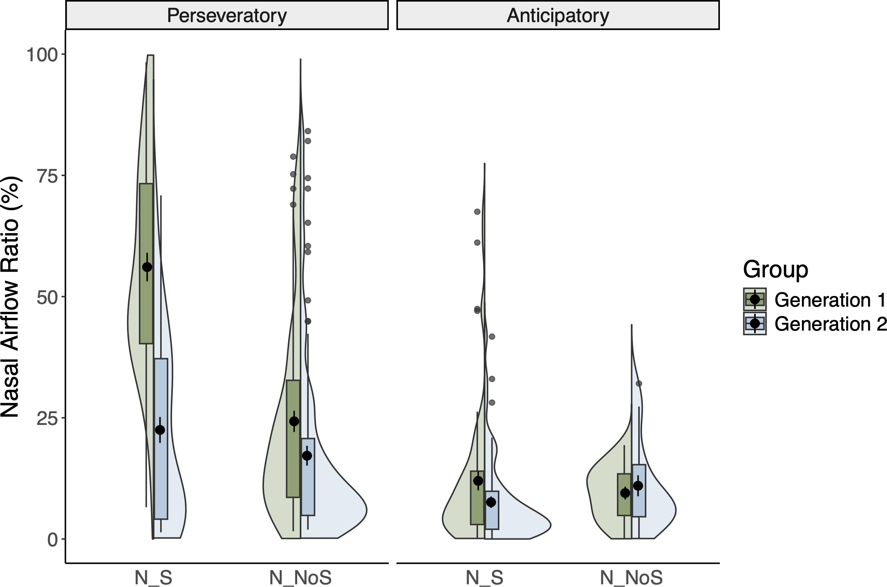
Figure 1:

Where:
N_S (with nasal, in stressed syllable)
N_NoS (with nasal, in unstressed syllable)

The Field is Here: Phonetic Documentation in a Diaspora Community
Grayson Ziegler (grzieg@iu.edu), Amanda Bohnert, Kelly Berkson, Samson Lotven – Indiana University
Past linguistic fieldwork often occurred overseas, but in 2025, dramatic changes in the funding landscape and factors like warfare and environmental change mean such work is not always feasible. Simultaneously, rates of forced displacement are higher than ever recorded (UNHCR 2024) and many languages are robustly spoken far from their geographic origin. As such there are plentiful opportunities for linguistic documentation in local communities—for fieldwork right next door to our academic institutions. In this talk, we introduce the model for phonetic documentation that we have developed as the Chin Languages Research Project (CLRP) and discuss our experiences working with the Indianapolis Chin diaspora community. In addition to sharing lessons learned, and some of the phonetic insights we have gained through this work, we pay special attention to the ethos and methodology which has facilitated the collection of plentiful phonetic data while placing community collaboration at the forefront. We emphasize the importance of building authentic relationships and of relational accountability (see Leonard 2021), and we articulate ways in which those values lead not only to strong collaborative communities but to better data and insights.
Indianapolis is home to the largest Burmese community in the United States (BACI 2023), upwards of 32,000 people. Most come from Chin State in western Myanmar, due in part to ongoing ethno-religious persecution and military violence (Salaz & Raymer 2020). The community is highly culturally and linguistically diverse—more than 30 Chin languages from the South-Central branch of Tibeto-Burman are spoken in Chin State, all of them under-documented and under- resourced. This same degree of diversity is now found in Indianapolis, meaning that not only are there an abundance of linguistic research opportunities just an hour from the Indiana University Bloomington (IU) campus, but there are also a complex array of language-related community needs and priorities. To pursue these scholarly and community goals in tandem, the CLRP was founded as a collaboration between researchers at IU and members of the Chin community, including many first-generation Chin students attending IU.
Through this collaboration, we have been able to document the inventories of many Chin languages, which display numerous typologically interesting properties. For example, languages of the Maraic subgroup of Chin languages, such as Lutuv (or Lautu), Zophei, and Zotung, have developed unusually dense and diverse vowel inventories due to shared historical rime simplification. Previous documentation was sparse and limited to anecdotal transcription. Nurturing long-term relationships with students on campus made previously uncomfortable laboratory settings feel more safe, paving the way for acoustic analysis, 3D/4D ultrasound, and the use of facial tracking software. The resulting data show that the picture is even more complicated than expected. For example, our data from Zophei and Zotung speakers show vowel inventories that (a) differ from previous description (e.g., Zotung, see Bohnert et al. 2024) and/or (b) show strong dialectal variation (e.g., Zophei, see Lotven 2021). Moreover, overlapping vowels can have radically different articulatory settings. In Lutuv, for example, acoustically high central vowels /ɨ ʉ/ are produced with a low tongue body (Ziegler et al. 2024) and visibly distinct lip and jaw postures (Bohnert & Berkson 2023). These observations broaden our understanding of articulatory and acoustic patterns of vocalic contrasts.
In sharing our experience conducting phonetic fieldwork, we hope to inspire other researchers to consider adapting the CLRP model of collaborative fieldwork for use in their own institutions or neighborhoods. In today’s world, diaspora communities are everywhere; speakers of under-resourced languages are right next door.

References

Bohnert, A., & Berkson, K. (2023). Lip posture of high and high-mid vowels in Hnaring Lutuv [Poster presentation]. 184th Meeting of the Acoustical Society of America, Chicago, IL. https://doi.org/10.1121/10.0019216
Bohnert, A., Berkson, K., Van Bik, K., & Ziegler, G. (2024). Vocalic contrasts in Zotung. [Poster presentation] 186th Meeting of the Acoustical Society of America. https://doi.org/10.1121/10.0027201
Bohnert, A., Ziegler, G., & Berkson, K. (2022). Vocalic contrasts in Hnaring Lutuv. [Poster presentation] 183rd Meeting of the Acoustical Society of America. https://doi.org/10.1121/10.0016307.
Burmese American Community Institute. (2023). Burmese population in the USA. BACI. https://thebaci.org/.
Leonard, W. Y. (2021). Centering Indigenous ways of knowing in collaborative language work. In L. Crowshoe, I. Genee, M. Peddle, J. Smith, & C. Snoek (Eds.), Sustaining Indigenous languages: Connecting communities, teachers, and scholars, 21-33.
Lotven, S. (2021). The sound systems of Zophei dialects and other Maraic languages [Doctoral dissertation]. Indiana University.
Salaz, S., & Raymer, S. (2020, December 12). Welcome to Chindianapolis. Indianapolis Monthly. https://www.indianapolismonthly.com/arts-and-culture/welcome-to- chindianapolis/
United Nations High Commissioner for Refugees. (2024). UNHCR global report.
Ziegler, G., Bohnert, A., Berkson, K., & Par, S. H. (2024). An ultrasound investigation of Lutuv (high?) vowels. [Poster presentation] 186th Meeting of the Acoustical Society of America. https://doi.org/10.1121/10.0027202.

When Early Exposure Isn’t Enough: Contrast-Specific Effects in Yoruba Phonological Perception
Matthew Ajibade, Indiana University Bloomington
maajibad@iu.edu

This study builds on recent work on the perceptual discrimination of Yoruba’s typologically rare labial-velar contrasts by examining how early exposure shapes perception of [gb]-[b] and [kp]- [gb] contrasts, both articulatorily and auditorily complex (Cahill 2006; Connell 1994). Research on phonological perception shows that early childhood exposure plays a critical role, often providing lasting advantages even when input is later interrupted (Chang, 2021). Yet, less is known about how such exposure shapes the perception of typologically rare contrasts, especially in understudied African languages. Yoruba is an ideal case, as it has complex labial-velar contrasts [kp]-[gb] and [gb]-[b] whose perceptual distinctiveness raises important questions about how input, contrast type, and long-term acquisition interact. To investigate this, we tested three listener groups (20 each) using an oddity discrimination task: (1) native Yoruba speakers with full exposure (NY), (2) heritage Yoruba speakers with limited or interrupted input (HY), and (3) native English speakers with no Yoruba exposure (NE). In the task, participants identified the odd item or indicated if all three items were the same. Group-level analyses revealed divergence in the contrasts. For [kp]-[gb], NY listeners outperformed both HY and NE, while HY listeners significantly outperformed NE, suggesting a gradient effect of input quality and continuity. For [gb]-[b], however, only NY listeners demonstrated strong performance. HY and NE listeners performed similarly, despite HY’s early childhood exposure. This asymmetry highlights contrast-specific differences rather than a universal advantage of early exposure: certain contrasts, such as [gb]-[b], may be inherently difficult to acquire or retain, regardless of early input. Individual-level analyses added further details. Heritage listeners showed greater variability than the other groups, reflecting differences in the type and quantity of early input.
Within both NY and HY groups, participants who varied in performance nonetheless showed relatively higher accuracy on [kp]-[gb] than [gb]-[b], again supporting the contrast-specific pattern. Interestingly, NE listeners, though generally performing poorly, showed slightly higher accuracy on [gb]-[b] than on [kp]-[gb], highlighting how sound-specific phonetic distinctiveness interacts with listener background. Taken together, the findings show that early exposure alone does not guarantee uniform success in acquiring or retaining phonological contrasts. Instead, outcomes reflect an interplay between input quality, perceptual salience, the nature of the sound, and individual differences. While early input is undeniably beneficial, the learnability and long- term retention of contrasts depend heavily on the specific properties of the contrast itself.

References
Cahill, Michael. 2006. Perception of Yoruba Word-Initial [gb] and [b]. In Olaoba F. Arasanyin & Michael A. Pemberton (eds.), Proceedings of the 36th Annual Conference on African Linguistics, 37-41. Somerville, MA: Cascadilla Proceedings Project. https://www.lingref.com/cpp/acal/36/paper1404.pdf
Chang, Charles B. 2021. Phonetics and phonology of heritage languages. In Polinsky, Maria, & Montrul, Silvina (eds.), The Cambridge Handbook of Heritage Languages and Linguistics, 581-612. Cambridge: Cambridge University Press.
Connell, Bruce. 1994. The structure of labial-velar stops. Journal of Phonetics 22(4). 441–476.

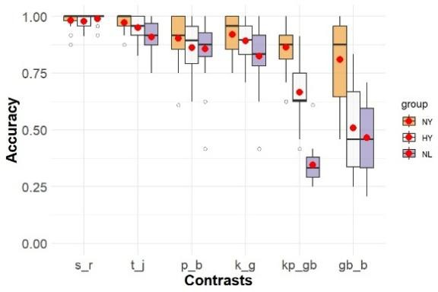

Figure 1. Group accuracy across six phonological contrasts for Native Yoruba (NY), Heritage Yoruba (HY), and Naïve Listeners (NL) who are Native English listeners. The x-axis represents contrasts. The y-axis represents accuracy. Boxplots show the distribution of accuracy within each group, with red dots indicating group means.
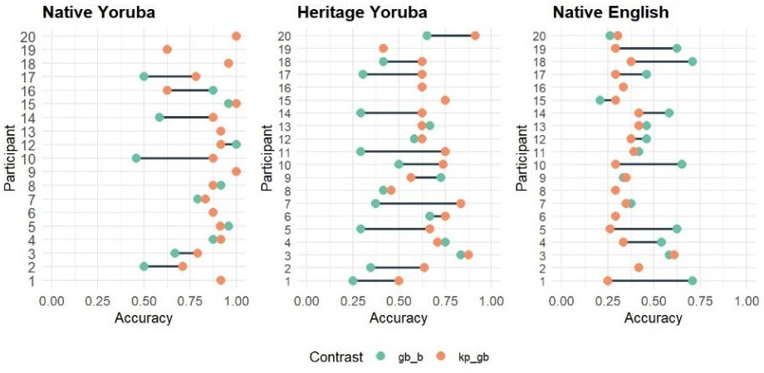

Figure 2. Accuracy by participant for two Yoruba contrasts: [gb]–[b] (green) and [kp]–[gb] (orange), across Native Yoruba (left), Heritage Yoruba (center), and Native English (right) listeners. The x-axis represents accuracy (0-1), and the y-axis lists individual participants (1–20) within each group. Lines connect each participant’s scores across the two contrasts, highlighting individual-level variation and contrast-specific perceptual patterns. An orange dot indicates equal discrimination of both contrasts.

Exposure to a Second Language Restructures the Phonotactics of Lexical Representations in the First Language. Evidence from Brazilian Portuguese
Yuri Sibucks, Indiana University, ysibucks@iu.edu, Isabelle Darcy, Indiana University, idarcy@iu.edu, Hunter Brakovec, hzbracov@iu.edu

L1 phonotactic knowledge shapes perception and production in the L1, e.g. in Brazilian Portuguese (BP; Dupoux et al, 2011): illicit sequences are perceptually repaired, and show low contrast sensitivity. Exposure to a second language (L2) with more permissive phonotactics can limit/reduce perceptual repairs in the L1 (Cabrelli et al., 2019). However, little is known about whether this alters the encoding of L1 phonolexical representations.
Studies on the lexical representation of BP mid-vowels (/e~ɛ, o~ɔ/) find variation in their encoding precision: L1 BP-speakers accept variation in mid-vowels even when it results in non- words (Authors, 2024). The source of this variation can be twofold: (Hypothesis A) Overall leniency towards variable forms due to exposure to English-accented Portuguese, or (Hypothesis B), as a result of learning English (phonotactics), their Portuguese lexical representations themselves have changed, resulting in leniency towards variants in specific phonotactic contexts.
To determine the potential role of phonotactics on the lexical representation of BP mid- vowels, we examined stressed mid-vowels in three contexts (Bisol & Veloso 2016): (a) obligatory phonotactic constraint: only close mid-vowels precede a nasal consonant (“N” context; e.g., ‘ameno’ /aˈme.nu/); (b) optional phonotactic tendency: open mid-vowels are more
likely in antepenultimate stress syllables (“Ante”; e.g., ‘ótimo’ /ˈɔ.͡tʃi.mu/); and (c) no clear phonotactic tendency (“Else”, e.g., ‘neto’ /ˈnɛ.tu/). Importantly, English has no constraint on pre-
nasal mid-vowels, nor tendency regarding antepenultimate mid-vowels.
Participants (n=40) were L1 BP adults with sequential L2 English. They completed auditory lexical decision (LDT) and preference judgement (PJT) tasks. Stimuli consisted of real target words containing a mid-vowel in the stressed syllable (TW; e.g., ‘caneta’ /ka.ˈne.tɐ/), target non- words created from the TWs by switching the mid-vowel (TNW; e.g., /ka.ˈnɛ.tɐ/), and additional control (non-)words. Participants also completed an AX discrimination task, a hearing test, and a background questionnaire to assess exposure to English, and to English-accented Portuguese.
Hypothesis A predicts a generalized effect of exposure to English-accented Portuguese, with more exposure leading to lower accuracy in rejecting non-words regardless of context. Yet, participants’ preference would still favor the real words (TW) over TNW. Hypothesis B (altering L1 phonolexical representations) predicts a context effect (not overall leniency): due to perceptual repairs, participants would accept variants (and be less accurate for TNW) more in N vs. other contexts, and (perhaps) in the Ante vs. Else context. Additionally, it predicts greater selection of ‘Both are equal’ in the PJT. In both tasks we expect an interaction with English exposure: greater exposure could reduce perceptual repairs and increase contrast sensitivity, leading to higher LD accuracy in N context
We found no effect of exposure to English-accented Portuguese in either task. A clear context effect emerged: in LDT, accuracy in the N context was much lower than in other contexts, and there was an interaction effect with English exposure: accuracy improved in the N context with increased English exposure. In the PJT, the ‘Both are equal’ option was chosen much more in the N context than the other contexts, but the likelihood of preferring the TW increased with English exposure. We interpret the results as supporting hypothesis B: fewer repairs lead to restructuring of the L1 phonotactic representations, and (slowly) increasing precision of the L1 phonolexical representations from L2 exposure, due to the greater pressure to encode contrasting mid-vowels.

Exploring variability in cross-language sibilant perceptual mapping
Tzu-Hsuan Yang, Jeff Holliday University of Kansas thyang@ku.edu, jjh@ku.edu
Introduction. The role of cross-language category mapping has been highlighted in models of L2 speech acquisition, but what factors may shape L2 learners’ perceptual mapping between L1 and L2 categories has been understudied. The current study examines the perceptual mapping between the Mandarin sibilant fricatives /s, ɕ, ʂ/, and English /s, ʃ/ by L1 Mandarin L2 learners of English. The perceptual mapping between these sounds is predicted to be highly variable due to phonotactic restrictions and orthographic differences between China and Taiwan. First, in Mandarin, /ɕ/ is in complementary distribution with /s/ and /ʂ/: Mandarin phonotactics dictate that only /ɕ/ may occur before /i/ but /s, ʂ/ may not, while /s, ʂ/ may directly precede other vowels (e.g., /sa/) but /ɕ/ may not (e.g., /ɕja/). We therefore predicted that English sibilants are more likely to map onto /ɕ/ before
/i/. In terms of orthography, retroflex /ʂ/ is spelled as sh in Hanyu Pinyin, a romanization system used in China, which is how /ʃ/ is often spelled in English. On the other hand, Taiwan has adopted Zhuyin, which shares no overlap with English letters. We thus predicted that Chinese listeners would be more likely to map English /ʃ/ to Mandarin /ʂ/ as opposed to /ɕ/ than Taiwanese listeners. Comparing how Chinese vs. Taiwanese listeners assimilate English sibilants will allow for examining whether and how these factors influence the perceptual mapping between L1 and L2 categories.
Method. We conducted two perception tasks––a perceptual assimilation task (PAT) and a similarity rating task (SRT)––to capture L2-to-L1 perceptual mappings on the phonetic and phonological levels, respectively (n = 38 Chinese listeners; n = 35 Taiwanese). The stimuli were English and Mandarin CVs with one of the sibilants followed by a vowel from among /a, i, ou/. In the PAT, participants heard an English CV and identified the best matching L1 sound from a list of all Mandarin sibilants, and provide a goodness rating. In the SRT, participants heard pairs of English and Mandarin CVs and rated their similarity on a visual analogue scale.
Results & Discussion. The PAT results showed that both Chinese and Taiwanese listeners assimilated English /s/ to Mandarin /s/. For English /ʃ/, while Chinese speakers showed a strong preference for the retroflex /ʂ/, Taiwanese listeners favored the alveopalatal /ɕ/ over /ʂ/. Closer inspection of results by vowel context revealed that when followed by /i/, both English /s/ and /ʃ/ were more likely to be assimilated to Mandarin /ɕ/ compared to in other vowel contexts. However, this trend was less pronounced for Chinese listeners, suggesting that perceptual assimilation between English and Mandarin sibilants indeed varies by the following vowel, but this effect is mitigated by orthography. The SRT results were largely consistent with those of the PAT, such that a higher similarity rating in the former generally corresponded to higher response rate in the latter. However, a few exceptions were observed: for instance, for Taiwanese listeners, 42% of English
/ʃa/ was assimilated to Mandarin /ɕja/ in the PAT, while this pair of sounds received a low similarity rating in the SRT. These results suggest that while listeners considered /ɕ/ an acceptable phonological mapping target for /ʃ/, they did not find these two syllables similar on a phonetic level. Taken together, our findings underscore that perceptual mapping is a multifaceted phenomenon shaped by the interplay of various factors, and that mappings should not be assumed based on acoustic similarity alone.

Alternative Implementations of the Latin Stress Rule
Brett Hyde, Washington University, bhyde@wustl.edu
The Latin Stress Rule (LSR), given informally in (1), has played an important role in the analysis of English primary stress beginning with Chomsky and Halle 1968.
- If penult is heavy, stress the penult. If the penult is light, stress the antepenult.
One of the most straightforward implementations of the LSR employs extrametricality and moraic trochees. In Hayes’ (1981) analysis of English nouns, final syllables are extrametrical and a moraic trochee is built just to the left of the extrametrical syllable. If the penult is heavy, as in (2a), it forms a foot on its own and receives primary stress. If the penult is light, as in (2b), the penult and antepenult together form a trochee, and primary stress occurs on the antepenult.
- a. …LHσ → …LH<σ> → …L(ˈH)<σ>
  - …LLσ → …LL<σ> → …(ˈLL)<σ>
The extrametricality implementation is straightforward, but it is incompatible with parallel frameworks that require exhaustive parsing of syllables into feet (Hyde 2002, 2016). It is also incompatible with autonomous grid approaches (Gordon 2002).
In this talk, I demonstrate how the metrical grid can provide alternative implementations of the LSR. These are compatible with both autonomous grid approaches (Gordon 2002) and approaches that employ both prosodic structure and metrical structure (Hyde 2002, 2016). The implementation is based on the principle of clash avoidance (Liberman and Prince 1977): the grid column corresponding to primary stress occurs as far to the right as possible without creating a clash configuration. (A clash configuration is one in which two entries on one level of the metrical grid do not have an intervening entry on the next level lower.) Two key assumptions are stated in (3).
- a. Final syllables have a secondary metrical prominence, but NONFINALITY (Prince and Smolensky 1993) prevents final syllables from supporting the primary prominence.
  - Light syllables map to the grid with a single base-level entry; heavy syllables map with two (Prince 1983).
If the final syllable has a secondary metrical prominence and the penult is heavy, as in (4a), then the primary metrical column can occur over the penult without creating a clash. If the final syllable has a secondary metrical prominence and the penult is light, however, as in (4b), then the primary metrical column must retreat to the antepenult to avoid clash. NONFINALITY prevents the primary metrical column from occurring over the ultima in either situation.

- a.
X
X X
X XX X
… L H σ
* X
X X
⪼
X XX X
… L H σ,
- X
X X
X XX X
… L H σ

X
X X
X X X
b. … L L σ

* X
X X
⪼
X X X
… L L σ,

- X
X X
X X X
… L L σ

The talk explores possibilities for implementing the LSR with a grid-based approach in the analysis of English primary stress.

-ative tressing and its possible relationship to schwa syncope
Stuart Davis (davis@iu.edu) and Bihua Chen (bc1@iu.edu), Indiana University
The first vowel of the English suffix -ative receives secondary stress in some words, such as in quálitàtive and ínnovàtive, and it is unstressed and reduced in others as in consérvative and imáginative. Both Nanni (1977) and Davis (1988) assume that the first vowel is underlyingly long, which is realized as a secondary stress in words like quálitàtive and ínnovàtive. In words like consérvative, and other words like it such as cáusative and evócative, the stress on the first syllable of the suffix destresses because of stress clash given that it is adjacent to the syllable with main stress. The destressing in imaginative, and words like it such as óperative and cúmulative is not due to stress clash, but as Nanni (1977) observed, to an apparent destressing effect of the sonorant consonant immediately before the suffix. Davis (1988) takes this to be a rule of destressing sensitive to the nature of the onset consonant. Thus, there is destressing in imáginative where the onset of the first syllable of the suffix is a sonorant but not in quálitàtive where the onset of the 1st syllable of the suffix is an obstruent. Stanton (2019) has a different view of stressing with the suffix -ative. She notes that in words like législàtive, where there is a consonant cluster before -ative, the tendency is to have stress on the 1st syllable of the suffix even though there is a sonorant consonant in its onset. She develops a view that the stress pattern on the suffix -ative reflects a constraint that disfavors a long phonetic lapse between two stressed syllables. If one compares législàtive with the hypothetical législatìve (where she indicates a secondary stress on the last syllable), the durational lapse in the latter is too long because of the consonant cluster; législàtive with a shorter lapse between the two stressed syllable is preferred. The effect noted by Nanni, that a single sonorant consonant immediately before the suffix -ative favors destressing, is on Stanton’s account, due to the durational shortness of the sonorant consonant (in contrast with an obstruent that would have longer duration). The implication is that for the hypothetical quálitatìve the durational lapse between the two stressed syllables is too long because of the longer duration of the obstruent /t/ before the suffix, so quálitàtive is preferred; but for a word like imáginatìve, the durational lapse between the two stressed syllables is not as long because of the relative shortness of the sonorant consonant /n/ immediately before the suffix. (Note that Stanton does not consider the first vowel of -ative to be underlyingly long, but there is a choice between the allomorphs [-ètɪv] and [-ət`ɪv] based on which allomorph best satisfies a phonetic lapse constraint). Our paper offers a different conception of -ative stressing and connects it to the well-known pattern of English Schwa Syncope (Zwicky 1972, Hooper 1978, Polgardi 2015 among many others) based on American English. The salient observation that we make is that the realization of the suffix -ative as [-ət`ɪv] in words like imáginative, óperative, and cúmulative seems to mimic the environment where English Schwa Syncope (henceforth ESS) is most preferred. Recall that there are two structural conditions that favor ESS. The resulting cluster for ESS should have rising sonority as exemplified by words like diágonal, ópera, and fámily, where syncope readily occurs (and where the target schwa is underlined in the examples given), as opposed to words like mélody, Cánada, and párody where ESS is strongly disfavored since the resulting cluster would have falling sonority if ESS were to occur. Second, ESS is typically prevented if it would result in a stress clash. Compare bróccoli vs. bròccolíni, where ESS is more likely in the former. In words like imáginative, óperative, and cúmulative ESS is fed when the suffix is pronounced as [-ət`ɪv] since deleting the schwa in the syllable before the suffix results in a cluster of rising sonority. For words like quálitàtive and ínnovàtive pronouncing the suffix as [-ət`ɪv] would not feed ESS since the resulting cluster would not have rising sonority. We offer an analysis referencing preferred foot structure in present day English

Perceptibility of prominence in French: Weight, cue weighting or “stress deafness”?
Jeffrey Lamontagne† (jlamonta@iu.edu), Kaitlyn Owens† (kaitowen@iu.edu), Jane Gilbert† (janegilb@iu.edu)
†Indiana University – Bloomington
Introduction. The nature of prominence in French has been at the center of considerable debate, from its formal description (e.g. stress in Cutler 2005, Schwab & Llisterri 2012; pitch accent in Jun & Fougeron 1995, Welby 2006; both in Lamontagne & Goad 2022; ambiguous in Vaissière & Michaud 2006; in flux in Fónagy 1980) to its acoustic profile (pitch, amplitude, duration; for an overview, see Lamontagne & Goad 2022). While details vary, the predominant description is that the language exhibits phrasal prominence conveyed using pitch (e.g. Jun & Fougeron 2000). Crucially, however, the question is whether lexical prominence (i.e. stress) is also computed, as argued by Lamontagne & Goad (2022) and Ulfsbjorninn (2022), with phrasal accents being attracted to stressed syllables as is typologically common (van der Hulst 2011, Gordon 2014).
For Quebec French, production analyses demonstrate that the location of prominence is sensitive to lexical factors (vowel weight in Thibault & Ouellet 1996; vowel and coda weights in Lamontagne & Goad 2022), with perception studies only having tested the effect of codas (Paradis & Deshaies 1990). However, the relative perceptual importance of acoustic cues, the relevance of lexical properties (here focusing on vowel and coda weight), and the salience of prominence shifts remain unclear. The current study addresses this gap, arguing against the
“stress deafness” ascribed to French speakers (e.g. Dupoux et al. 1997, Peperkamp & Dupoux 2002) on the basis that the cause is – at least in part – rooted in an incomplete analysis of the French prominence system (or the stimuli used) and in greater complexity in cue weighting and cue usage than frequently assumed in the literature (see Lamontagne & Goad 2022).
Methods. 19 native speakers of Quebec French residing in Quebec, Canada, heard 18 disyllabic monomorphemic French words balanced for initial onset (present, absent) and penult and coda weights (open with light vowel, open with heavy nasal vowel, closed by a sonorant), with each presented alongside a determiner with each resynthesized permutation of amplitude (flat, higher penult, higher final), duration (equal, longer penult, longer final) and pitch contour (HM, HL, LH). Participants rated each token for naturalness on a scale from 1 to 6. The 9234 ratings were analysed using affinity propagation clustering (to cluster participants by response profile) and mixed-effects linear regression (for conditioning of ratings within participant clusters).
Results and discussion. Our results reveal distinct profiles (clusters) of participants. Two participants accepted every prosodic profile as fully natural. Otherwise, ratings were variably sensitive to acoustic cues: duration sensitivity was most consistent (long final rhymes favoured by default), but amplitude and pitch effects differed across clusters. For rhyme weight, several clusters favour increased prominence for closed syllables, while a smaller subset favour it for open syllables containing a nasal vowel. The latter case often patterns flexibly, capable of being treated as heavy or light depending on the word and on the other syllable’s weight, with heavy- patterning nasal vowels often exhibiting longer duration, higher amplitude, and higher pitch. We further observe that, while acoustic cues to prominence are somewhat independent, there appears to be a closer match between amplitude and duration, as suggested based on production and based on typological correlates of lexical stress in Lamontagne & Goad (2022). Taken together, our study argues for an updated description of the prosodic system in (Quebec) French as combining lexical and phrasal components, with the importance of weight being reinforced and validation that “stress deafness” may result from cue usage and phonological factors not generally assumed to be important for French, as well as collapsing data across participants.

An empirical argument for Mora Theory over X-Slot Theory: weightless nuclei in English /iu/ Scott Borgeson, Michigan State University
borges11@msu.edu

Two views of syllable structure predominate: Mora Theory (MT) and X-Slot theory (XST). Although theoretically distinct, they are notoriously difficult to tease apart empirically, since both can explain the basic facts of syllable structure with roughly the same degree of stipulation. In this talk, I present evidence from a novel analysis of the English diphthong /iu/ that supports a modified version of MT, but is wholly incompatible with the basic logic of weight calculation in XST.
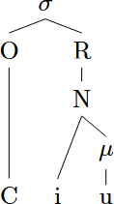
To begin with, XST is structurally richer than MT: while XST posits discrete nodes corresponding to the nucleus (N) and rhyme (N’), MT posits only a syllable node, and makes use of moraicity and linear order to draw all other distinctions. To make the comparison between the two theories fair, then, we must re-introduce structure to MT. In fact, this is necessary anyway in order to account for the existence of moraic onsets in languages such as Trukese (Churchyard 1991, Davis & Torretta 1998) and Pattani Malay (Yupho 1989, Hajek & Goedemans 2003, Topintzi 2010). I therefore propose that we adopt distinct nodes corresponding to the onset (O), nucleus (N), rhyme (R), and coda (K), and make use of moras for their traditional function in encoding weight. The resulting theory, which I term Enriched MT, decouples weight from position, and thus predicts the existence of moraic onsets as well as non-moraic nuclei.
I further argue that non-moraic nuclei are indeed attested in the English diphthong /iu/, which I argue has the structure shown to the right: /i/ is non- moraic, but still belongs to the nucleus by virtue of its association with the nucleus node (N) rather than the onset node (O). This structure explains a number of interesting properties of this phoneme. First, as noted in Davis & Hammond (1995), /i/ does not behave like an onset with respect to language games; as noted above, this is true of the structure I posit. Second, /iu/ fails to attract stress in words like amulet, and thus must be monomoraic (ibid.); once
again, this is true of the structure I posit. To these, I add the (to my knowledge) novel observation that /iu/ patterns like a long vowel in being incompatible with a following coda consonant. For example, pink is acceptable (it contains a short vowel followed by coda [ŋ] and extrametrical [k]), but *[pi:ŋk] and *[piuŋk] are not. This too is captured by the structure above: because /iu/ is bipositional, it cannot be followed by a moraic coda without violating maximal binarity. In short,
/iu/ occupies space within the nucleus, but does not contribute weight to it.
Weightless nuclei are possible in Enriched MT precisely because the theory disentangles the notions of weight (encoded in moras) and position (encoded in the onset vs. nucleus node). However, it cuts against the foundational logic of XST. In XST, all segments require X-slots in order to be pronounced, and all X-slots within the nucleus are guaranteed to contribute weight to the syllable no matter where weight is calculated (N vs. N’); as a result, “weightless nucleus” is simply a contradiction in terms. If the above account of English /iu/ is correct, then, it provides empirical evidence in favor of (Enriched) Mora Theory, and against X-Slot Theory.

Davis, S. & Hammond, M. (1995) – On the status of onglides in American English. Phonology 12(2), 159-82.

Approaching Mandarin glide affiliation from the perspective of gestural timing
Anqi Shao¹, Yichen Wang¹, Yunting Gu¹, Karthik Durvasula¹ ¹Michigan State University
shaoanqi@msu.edu, wangy176@msu.edu, guyuntin@msu.edu, karthikd@msu.edu
In Mandarin, glides (/j/, /w/ or /ɥ/) are permitted between consonants and vowels. However, the syllabic position of glides is unclear. Previous studies, based on language games (Bao, 1990; Wang & Chang, 2001; Lin, 2019) and speech errors (Wan, 2007), show inconsistent results. In this study, we try to address this question through timing relationships between the gestural movements of the glide and adjacent sounds. Electromagnetic Articulography (EMA) is used to record movements in Mandarin syllable production. Preliminary results suggest that the glide occupies a position independent of the onset consonant and vowel.
We adopt the hypotheses in Shaw et al (2021), who claim that a gesture links to either the onset of the preceding gesture (synchronous) or the offset of the preceding gesture (sequential). Gestures are synchronous in complex segments but are sequential in clusters. If two gestures are synchronous, lengthening of one gesture does not affect the onset lag between them. If the two gestures are in sequence, the lengthening of G1 delays G2’s onset and leads to a positive correlation between the increase in G1 duration and in G1-G2 onset lag. See Figure 1 for illustration. Independently, others have argued that CV sequences are typically synchronous (Liu et al, 2020).
Based on the above, there are 4 possibilities: (a) the glide is a secondary articulation of the onset consonant (Duanmu, 2007). Prediction: glides are synchronous with the consonant and the vowel;
(b) the glide is part of the onset but is in a sequential relation with the consonant (Bao, 1990). Prediction: glides are sequential with the consonant but synchronous with the vowel; (c) the glide is part of the nucleus and forms a diphthong with the vowel (Wang & Chang, 2001). Prediction: the glide and the consonant are synchronous, while the glide and the vowel are sequential; (d) the glide occupies an independent structural position from the onset consonant and the vowel (van de Weijer & Zhang, 2008). Prediction: glides are sequential with both the consonant and the vowel.
We conducted an EMA study with twenty Mandarin native speakers. Data from eight participants have been analyzed so far. Stimuli include six mono-syllabic words in the form of CGV and GV. In CGV stimuli, CG are either labial stop and palatal glide /j/ sequence (n = 6), or an alveolar stop and velar glide /w/ sequence, and V stands for a rime /an/ or /au/. GV stimuli are /j/ or /w/ followed by a rime /an/ or /au/. The words are embedded within the carrier phrase zhe-ge “ ” ma? (Is this “ ”? ). Sensors placement is shown in Table 1. Fifteen randomised lists of all the stimuli were produced by each speaker. G1 duration is computed as the interval between first gesture’s onset and offset; G1-G2 onset lag is the interval between the gesture onset and the following gesture onset. Figures 2(a, c) indicate a positive correlation between G1 duration and G1-G2 onset lag for both consonant-/j/ sequences (𝛽 =.624, p<.001) and consonant-/w/ sequences ( 𝛽 = .556, p < .001), suggesting that both the palatal glide and the velar glide are sequential with the onset consonant. Figures 2(b, d) indicate a positive correlation between G1 duration and G1-G2 onset lag for both /j/- vowel sequence (𝛽=.827, p<.001) and the /w/-vowel sequence (𝛽 = .107, p = .265), suggesting that both glides are also in sequential relation with the following vowel.
The preliminary results suggest the glide is a separate segment, rather than forming a complex segment with the onset consonant or the nuclear vowel. Next, we will check if there is c-center effect in CG (Browman & Goldstein, 1988) to further probe if the glide is part of a complex onset or a separate syllabic position between the onset and the vowel.

Measurement Target Segment
Lip Aperture (LA) Euclidean distance between upper and lower lip sensors - labial
gesture in labial stops

Tongue Tip (TT) Tongue tip gesture --- alveolar stops

Tongue Blade (TB) The palatal gesture in the palatal glide /j/

Tongue Dorsum (TD) (i)The tongue dorsum gesture in the velar glide /w/
(ii)The tongue dorsum gesture in the post-glide vowel

Nasion (N),
Left Mastoid (LM), Right Mastoid (RM)
(Reference sensors for head movement correction)

Table 1. Measurement for each target segment

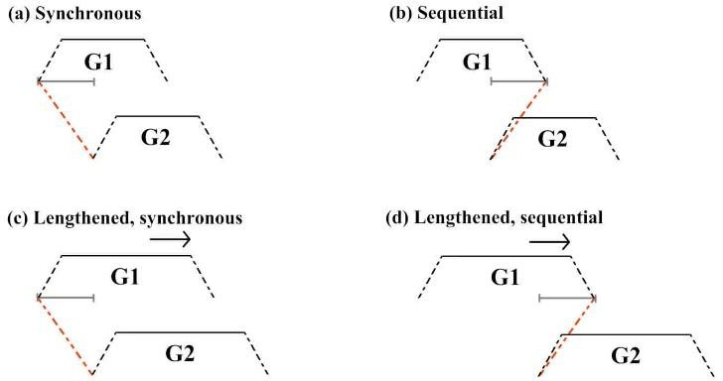

Figure 1. Timing relation between two gestures: (a) G1 and G2 are synchronous; (b)G1 and G2 are sequential; (c) synchronous G1 and G2 are lengthened and the G1-G2 onset lag is identical with (a); (d) sequential G1 and G2 are lengthened and the G1-G2 onset lag increases.
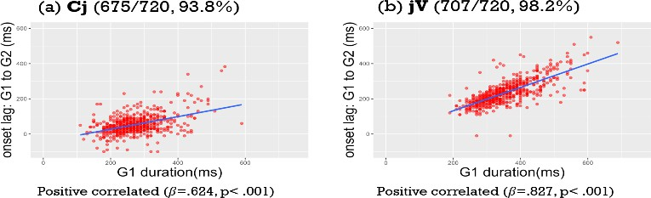
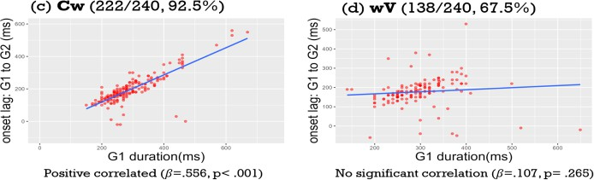

Figure 2. G1-G2 onset lag by G1 duration for (a) labial stop – palatal glide; (b) palatal glide – vowel; (c) alveolar stop – velar glide; (d) velar glide – vowel. Note: Data beyond 2σ are excluded as outliers; some tokens are discarded due to blending with other segments

Acoustic Convergence in Shadowing an Unfamiliar Language and Accent: VOT and Vowel Quality
Zeyu Feng¹, Olga Dmitrieva¹, Yuhyeon Seo², Alexis N. Zhou, Amy E. Hutchinson³ ¹Purdue University, ²State University of New York Oswego, ³Carleton College
feng454@purdue.edu, odmitrie@purdue.edu

Acoustic convergence occurs when speakers modify their speech to sound more like their
interlocutors. Existing research has primarily examined the effects of phonetic and social factors on native speakers’ convergence to familiar dialects of their native language (Babel, 2012;
Bradshaw & McGettigan, 2021; Clopper & Dossey, 2020; Pardo et al., 2018). The study explores convergence in voice onset time (VOT) and vowel quality for speakers imitating a model talker speaking a novel language or a novel accented version of the imitators’ native language.
The study recruited 60 native speakers of American English, who were randomly assigned to the Russian-accented English condition or the Russian condition. In the pre-test and post-test phases, all participants read English CVC words. Target English words included word-initial aspirated
voiceless stops [p^{h}, t^{h}, k^{h}] with long-lag VOT and vowels /ɑ, ɪ, ʌ/. In the exposure phase,
participants heard a model talker reading words and identified the initial or final sound of each word. The model talker was a native speaker of Russian. Participants in the Russian-accented English condition were primed with an expectation to hear the Russian speaker reading English words, whereas participants in the Russian condition were informed that they would hear the Russian speaker reading Russian words. In the shadowing phase, participants repeated after the
model talker the same words they had previously heard during the exposure phase. The exposure and shadowing phases used the same recording of Russian CVC words (Russian-English near-
homophones). Target Russian words included word-initial unaspirated voiceless stops /p, t, k/ with short-lag VOT (English counterparts: [p^{h}, t^{h}, k^{h}]) and vowels /o, i, a/ (English counterparts:
/ɑ, ɪ, ʌ/). Vowel quality analysis was conducted on 54 participants’ data, and VOT analysis was conducted on 30 participants’ data. VOT durations of word-initial stops and F1, F2, F3 of vowels in the target words in the pre-test, shadowing, and post-test recordings were measured. Mixed- effects linear models were used for statistical analysis. Participants in the Russian-accented
English condition showed no significant changes in VOT across phases, indicating no convergence to the short-lag VOT in Russian word-initial voiceless stops. In contrast,
participants in the Russian condition reduced VOT durations considerably in shadowing. All participants showed significant convergence to Russian vowels /o/ and /a/ in shadowing, with
stronger effects in the Russian condition. Convergence to Russian vowel /i/ was only observed in the Russian condition. However, none of these convergence effects persisted into the post-test.

Convergence was stronger in the Russian condition than the Russian-accented English condition, indicating that participants were more willing to imitate acoustic features of an unfamiliar
language than to imitate an accented version of their native language. This suggests that acoustic convergence is shaped by listeners’ beliefs about the speech input. Further research could
investigate how cognitive, linguistic, and social factors influence individual variation in acoustic convergence. The lack of post-test effects shows that convergence may reflect transitory mimicry instead of stable speech learning. While speakers can temporarily adapt their acoustic properties to unfamiliar input during spontaneous imitation, more sustained and varied exposure may be
necessary for persistent change, offering insights into L2 speech training, phonological acquisition, and contact-induced sound change.

Between sound and style: Acoustic analysis of the coda /ɾ/ in the Dominican News Macy Maas | Indiana University
Macymaas@iu.edu

This paper examines the production of Spanish coda /ɾ/ by newscasters in the Dominican Republic, comparing their speech to previously documented productions by middle- and lower- class speakers. The purpose is to better understand how news speech, which is known for its hypercorrection and careful articulation (e.g., Alba, 2011), differs from everyday speech patterns of these groups. The coda /ɾ/ in Dominican Spanish exhibits several allophonic variants including [l], [ɾ], [i], [r], elision, and a merged lateral-rhotic variant (Willis & Ronquest, 2022), with lambdacism documented as occurring in the east and vocalization occurring in the northeast (Navarro Tomás, 1956; Willis & Díaz-Campos, 2021).
This study uses data extracted from YouTube from three nationally broadcasted channels. The first 50 tokens of coda /ɾ/ produced by ten Dominican newscasters (five men, five women) were analyzed, yielding 500 tokens. Using Praat (Boersma & Weenink, 2024), the tokens were categorized into three groups: zero occlusions (includes regional variants), one occlusion, (tap) and two or more occlusions (trills). These categories were used to aid in the analysis of what type of variant Dominican newscasters use more: a regional variant, normative variant, or hyperarticulated variant.
My results indicate that the majority of coda /ɾ/ productions (69.6%) contained one occlusion,the normative variant. This contrasts with the findings of Willis & Ronquest (2022), where only 56.2% of tokens were taps, which suggests the occurrence of hypercorrection. The category with zero occlusions varied even more with Willis & Ronquest (2022), reporting 43.8% of their productions being in that category while the newscasters analyzed produced only 21.4%, and lastly, Willis & Ronquest (2022) reported no instances of [r].
These results suggest that newscasters, likely due to the performative nature of news speech, tend to favor the tap variant, reducing the occurrence of regional variants typically associated with Dominican Spanish. This pattern could reflect both linguistic insecurity and the influence of the newsroom context.

References
Alba, O. (2011). Hipercorrección en los programas de noticias en la televisión de la República Dominicana. In
R. Ávila, R. Muñoz, & C. Garduño (Eds.), Variación del español en los medios (1st ed.). Colegio de México.
Boersma, P., & Weenink, D. (2024). Praat: Doing phonetics by computer [Computer program]. Version
6.4.18. http://www.praat.org/
Willis, E., & Díaz-Campos, M. (2021). The perception of coda liquids in Dominican Spanish: Geographic and social variation. In L. A. Ortiz-López & E. M. Suárez-Büdenbender (Eds.), Topics in Spanish linguistic perceptions (pp. 35–53). Taylor & Francis.
Willis, E., & Ronquest, R. (2022). A sociophonetic exploration of coda liquids and vocalization in Cibao Dominican Spanish. In M. Díaz-Campos (Ed.), The Routledge handbook of variationist approaches to Spanish (pp. 207–230). Routledge.

ATR Domains and Interactions in Akan Grammar: Towards a comprehensive account of the Emergence of Surface [+ATR]
Author name and Affiliation:
Seth Antwi OFORI, African Studies, Indiana University – Bloomington

Author email address:
sofori@iu.edu, sofori@gmail.com

Abstract

This paper aims to provide a comprehensive account of [+ATR] harmony in Akan and shows the importance of contextual (i.e., morphological) information in this account. Paired below are the ten vowel sounds in Akan in [-ATR]/[+ATR]: [ɪ/i, ʊ/u, ɛ/e, ɔ/o, a/æ]; phonemic [-ATR] vowels /ɪ, ʊ, ɛ, ɔ, a/ change to their phonetic counterparts of the pairing during [+ATR] harmony (Dolphyne 1988). Primarily, this paper addresses the following issues so to provide a more adequate account on the phenomenon in Akan grammar. First, there are salient contextual information that previous accounts did not identify (Owusu 2022, 2014, Lass 1984), but which are significant in reaching a more definite and adequate conclusion on how [+ATR] harmony works in Akan. Second, there are linguistic phenomena that previous accounts missed (Owusu 2022, 2014, Dolphyne 1988, Lass 1984) which significantly interact with [+ATR] harmony and join with it to cause unique harmonic effects on outputs. Following are some of the approaches to be followed and some initial observations on [+ATR] harmony in Akan. The following three morphologically-based vowel categories are identified which are significant to a comprehensive account of [+ATR] harmony in Akan: (i) Lexical [+ATR] – i.e., root-based [+ATR] vowels; (ii) Non-lexical [+ATR] – i.e., bound morphemic-based [+ATR] vowels; and (iii) Lexicalized [+ATR] –i.e. derived root-based [+ATR]. The significance of these categories will become clear in actual [+ATR] analysis. Constraints on [+ATR]-sequencing and modes of resolution are guided and guarded by the above morphological considerations. Also, it will be shown how [+ATR] harmony in Akan is not always an independent phonological process as has been presented in the existing works. There are instances where [+ATR] vowels must interact with other phonological units, or where [+ATR] harmony teams up with other phonological phenomena, to derive outputs. Working within OT, following are some of the constraints identified so far: (i) OCP[-lo]-LEX – avoidance of a sequence of two or more non-lexical, non-low vowels; (ii) OCP[+low]+CONTIG – avoidance of a sequence of uninterrupted low ([-ATR]) vowels; (iii) *[-ATR]+LEX[+ATR]+LEX(‘ZED) – no unadvanced lexical vowel to precede a lexical or lexicalized [+ATR] vowel; (iv) *[-ATR]- LEX[+ATR]+LEX(‘ZED) – no unadvanced non-lexical vowel to precede a lexical or lexicalized [+ATR] vowel; (v) *[+ATR]+LEX[-ATR]-LEX – no unadvanced non-lexical vowel to succeed a lexical [+ATR] vowel; (vi) *[+Low, +ATR]-LEX[-Hi/-Lo, +ATR+LEX] – no unadvanced non-lexical low vowel to precede a lexical [+Mid] [+ATR] vowel, etc.

What is Narrow Transcription?
San Duanmu University of Michigan duanmu@umich.edu

According to the IPA, phonetic transcription involves two steps. In the first, speech is divided into segments (phones), which are transcribed as is (narrow transcription). In the second, phonemic analysis is applied, which groups segments into phonemes, yielding a phonemic transcription (broad transcription). There is an outstanding question in the first step though: How narrow should narrow transcription be? On one hand, it is unrealistic, or impossible, to transcribe all measurable differences; for example, everyone’s pronunciation of /i/ (or any other phoneme) is different, and for the same person, every token of /i/ is different. On the other hand, we do want to overlook any difference that could turn out to be contrastive in the target language, or in in another language. The balance lies between the two extremes, but the IPA left the location of the balance to the field linguist. It is understandable that the IPA was unable to offer an answer to the question in the early days, since no one had enough understanding of the diversity of the world’s languages. Today, however, we know a lot more about the world’s languages, and it is possible to offer the answer, at least in principle. I propose in (1) a principle of contrast for narrow transcription (POC-NT), in contrast to the traditional principle of contrast for phonemic transcription (POC-PT) in (2).

- The Principle of Contrast for narrow transcription (POC-NT) Let A and B be two segments that are similar in some ways
  - If A and B are contrastive in a known language, they are different.
  - If A and B are not contrastive in any known language, they are the same.

- The Principle of Contrast for phonemic transcription (POC-PT) Let A and B be two segments that are similar in some ways,
  - If A and B are contrastive in a language, then they belong to different phonemes in that language.
  - Otherwise, A and B belong to different phonemes.

To obtain a complete system of known contrasts, POC-NT requires the use of phoneme inventory databases, such as UPSID, P-base, and PHOIBLE. I shall illustrate how this is done.

1

Poster session 1 abstracts

Neither Pitch Height nor Tonal Alignment Alone Contrasts Feixiang Chinese Falling Tones
Jianfeng Steven Guo (jg31@illinois.edu), University of Illinois Urbana-Champaign

Introduction. This study examines the acoustic correlates of the two lexical falling tones in Feixiang Chinese
(FC), an under-studied variety of Jin Chinese. It is widely assumed that tonal alignment—the timing of fundamental frequency (F₀) patterns relative to segmental sequences (Remijsen, 2013)—in contour tones within a syllable is not contrastive (e.g., Hyman, 1988; Odden, 1995). However, recent research has challenged this view: contrastive tonal alignment has been reported for falling tones in Dinka (Remijsen, 2013), Shilluk (Remijsen & Ayoker, 2014), and Zhumadian Mandarin (Gussenhoven & van de Ven, 2020). This study provides new evidence bearing on this discussion.
Method. The productions of monosyllabic falling-tone minimal pairs were drawn from a larger tone inventory study of FC. Six native speakers recorded themselves at home using phones and head-mounted microphones. Recordings were annotated in Praat with ProsodyPro (Xu, 2013), with rhyme intervals marked from the onset of F2 to the earliest sign of offset (Rose, 2019). Each contour was represented by 40 time-normalized F₀ values (in semitones). F₀ and duration were z-transformed per speaker to control for inter-speaker differences. Tokens were excluded if they involved mispronunciations or exceeded 2.5 standard deviations and were visually aberrant. The final dataset included 298 falling-tone items (146 Fall 1, 152 Fall 2).
Data Analysis. Differences in the overall pitch contour trends of the two falling tones were examined using a GAMM, with F0 values as the dependent variable, tone type as a fixed effect, time as main smooths, and speaker and syllable as random smooths. Potential differences in acoustic features (e.g., F0 maximum, timing of F0 maxi- mum, duration) were assessed with linear mixed-effects models. Features with significant differences were further examined to evaluate their role in distinguishing the two tones. Because these features were highly correlated, a principal component analysis (PCA) was conducted, and the resulting principal components (PCs) were then used to fit a logistic regression mixed-effects model with speaker and syllable as random effects.
Results. The GAMM (adjusted R² = 0.699) results revealed significant differences in the latter half of the
pitch contours (approximately 43–100% of the rhyme), where differences were observed in F0 slope, curvature, and related measures (See Figure 1 in Appendix). By contrast, the region around the F0 maximum was not significant. Linear mixed-effects models of individual acoustic features confirmed these results and further showed that the timing of the F0 maximum was significant. The first three PCs, which accounted for 91.6% of the total variance, were retained for further analysis (See Figure 2 in Appendix). . Examination of the loadings showed that PC1 reflects the dynamism of the falling contour, capturing F0 slope, curvature, minimum, and range, while PC2 and PC3 both reflect temporal characteristics, with PC2 dominated by duration (and F0 maximum timing secondary) and PC3 dominated by F0 maximum timing (and duration secondary).
The logistic regression model results showed that PC1, PC2, and their interactions with PC3 were significant (p < 0.05, adjusted R² = 0.74). PC1 (part R² = 0.65) and PC2 (part R² = 0.64) were the dominant contributors to the fixed effects, while the unique interaction components were relatively minor: PC2 × PC3 (part R² = 0.14) and PC1 × PC3 (part R² = 0.03). A more dynamic falling contour (larger PC1) and a shorter duration (larger PC2) decreased the likelihood of Fall 2. Interaction analyses further indicated that the effect of pitch movement was weakened when the peak occurred later, whereas the effect of duration was weakened when the peak occurred earlier.
Conclusion. The study shows that the falling tones in FC are not contrastive in F0 maximum, but differ significantly in F0 minimum, contradicting Yip (2002)’s claim that contour tones of the same shape would differ pitch height. Nor is their contrastiveness solely encoded in tonal alignment. Rather, the findings reveal a more nuanced picture in which both pitch movement (e.g., fall size, slope) and temporal dimensions (duration and tonal alignment) contribute to the distinctiveness of the falling tone contours. As pitch movement becomes more dynamic (i.e., a larger and faster fall), the likelihood of being identified as Fall 2 decreases. Moreover, tonal alignment interacts with pitch movement and duration, though in opposite directions.

Appendix: Figures and References

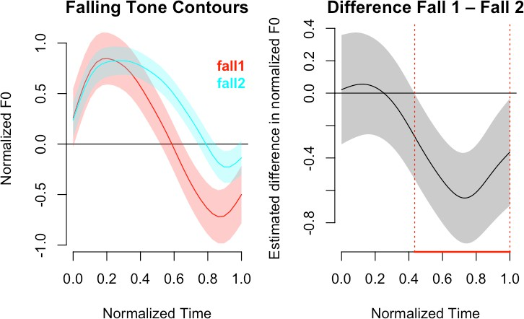
Figure 1: Generalized Additive Mixed Model (GAMM) results for the two falling tones.

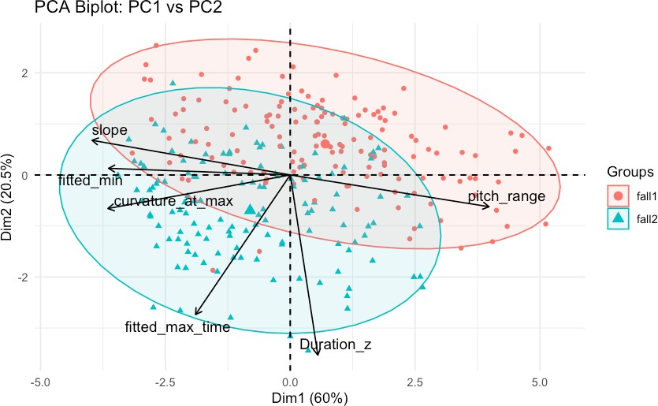
Figure 2: Biplot of the first two principal components with feature loadings

References
Gussenhoven, C., & van de Ven, M. (2020). Categorical perception of lexical tone contrasts and gradient perception of the statement–question intonation contrast in Zhumadian Mandarin. Language and Cognition, 12(4), 614– 648.
Hyman, L. M. (1988). Syllable structure constraints on tonal contours. Linguistique Africaine, 1, 49–60.

Odden, D. (1995). Tone: African languages. In J. A. Goldsmith (Ed.), The handbook of phonological theory (pp.
444–475). Oxford: Blackwell.
Remijsen, B. (2013). Tonal alignment is contrastive in falling contours in Dinka. Language, 89(2), 297–327.
Remijsen, B., & Ayoker, O. G. (2014). Contrastive tonal alignment in falling contours in Shilluk. Phonology, 31(3), 435–462.
Rose, P. (2019). Tonatory patterns in Taizhou Wu tones. In Ichps 2019 19th international congress of phonetic sciences.
Xu, Y. (2013). ProsodyPro - A tool for large-scale systematic prosody analysis. Proceedings of Tools and Resources for the Analysis of Speech Prosody, 7–10.
Yip, M. (2002). Tone. In (p. 29). Cambridge: Cambridge University Press.

- Toward development of a multitalker assessment of speech recognition in noise under
variable cognitive demands Daniel Fogerty
University of Illinois Urbana-Champaign dfogerty@illinois.edu

The Digits-in-Noise test has become a widely successful self-assessment of hearing
function that captures a listener’s ability to recognize speech in noise. It has been adopted worldwide and is available in many languages. In the standard implementation, the
listener repeats a sequence of three digits presented in a “steady-state” speech-shaped
noise. Such measures give an indication of a listener’s ability to recognize speech in noise but do not capture many of the factors that create difficult listening conditions. Two factors that contribute to listening challenges are talker variability and cognitive load. Variations in speech intelligibility across talkers is widely documented, but little is known about how these talker differences affect speech recognition thresholds or listening effort using the Digits-in-Noise test. This pilot study obtained speech recognition thresholds from a group of younger normal hearing listeners for six different talkers (three male and three female).
To investigate how cognitive load might influence results, testing was completed in two response conditions that involved repeating the digits forward or backward. Response time was also calculated at the listener’s threshold. Results demonstrated variations in talker intelligibility (by as much as 4 dB) that remained consistent across the two response conditions. Response times were significantly slower in the backward condition. Results indicate that the Digits-in-Noise test is sensitive to variations in talker intelligibility. Results will be used to develop a multitalker version of the test to assess listener sensitivity to
factors such as talker variability and listening in multitalker environments.

3

Introduction

Italian-American identity through phonology Lindsey Bishop-Allen, The University of Kentucky bishop.allen@uky.edu

A symbol of ethnic identity, the Italian-American dialect is largely unexplored despite the significant presence of Italian-Americans in the United States (Pagliai, 2005; De Fina, 2014). This study investigates the phonology of a second-generation Italian-American’s speech and discusses phonological phenomena taking into account the participant’s family history and past collective sentiments towards Italian-Americans.

Methodology
The participant in this case study was a second-generation Italian-American male who was born in 1942 to parents who had immigrated to the United States (western Pennsylvania) from southern Italy. Speech data was collected by means of an informal interview and observation in natural discourse, and this data was compared with Italian phonological patterns (Rogers and d’Arcangeli, 2004) and with known features of Italian English (Chambers, 2008, De Fina, 2014).

Results/Discussion
Italian-informed phonological deviations included backing as evidenced by changing the consonant cluster “ndw” (thereby changing pronunciation of “sandwich” to /seŋg wIt∫/), and monophthongization/backing of /aɪl/ to /ɔl/ and /aʊər/ to /ɑr/. This backing is unsurprising as Italian vowels tend to be pronounced farther back in the mouth than English vowels (Rogers and d’Arcangeli, 2004), and Chambers has even discussed the case of sangwich specifically (2008). The speaker was also able to discuss some of the Italian language influence on his parents’ English, such as omission of the voiced interdental fricative. The participant is monolingual, only speaking English. When asked why he did not learn Italian from his parents, he responded that due to attitudes towards Italian-Americans when he was growing up, his parents deliberately did not teach him Italian. This is consistent with anti-Italian bias described by Luconi (2011).
Though the speaker does not speak Italian, his speech still carries vestiges of his ethnic heritage, which he is proud of.

References
Chambers, C. K. (2008). Sociology of immigration. In Social dialectology: In honour of Peter Trudgill (pp. 917–113). Impact.
De Fina, A. (2014). Italian and Italians in the United States. In Handbook of heritage, community, and native American languages in the United States: Research, policy, and educational practice (1st ed., pp. 123–131). Routledge.
Luconi, S. (2011). Discrimination and Identity Construction: The Case of Italian Immigrants and their Offspring in the USA. Journal of Intercultural Studies, 32(3), 293–307.
Pagliai, V. (2005). Italians in the United States. In: Ember, M., Ember, C.R., Skoggard, I. (eds) Encyclopedia of Diasporas. Springer, Boston, MA.
Rogers, D., & d’Arcangeli, L. (2004). Italian. Journal of the International Phonetic Association, 34(1), 117–121.

4 Segmental constraints limit the impact of communicative factors on English CV
coarticulation
Chang Wang, Allard Jongman (University of Kansas) changwang@ku.edu, jongman@ku.edu
Coarticulation, the temporal and spatial overlap of speech gestures, is a central source of variability in continuous speech. Previous research has shown that both segmental and global factors influence the degree of coarticulation. The Degree of Articulatory Constraint (DAC) model posits that the degree of coarticulation varies systematically with segment-specific articulatory constraints (Recasens, 1985; Recasens et al., 1997): highly articulatorily-constrained segments, such as palatals and fricatives, exhibit greater resistance to coarticulation, while less constrained segments, such as labials, are more susceptible. Global factors also shape coarticulatory patterns. Lindblom's (1990) H&H theory predicts reduced coarticulation in hyperarticulated clear speech, while faster speech rates increase coarticulation due to more overlap (Agwuele et al., 2009).
Little work has systematically tested how segmental constraints interact with style and rate across a wider set of consonants and vowels. The present study examines the interaction between segments, style and rate in English CV syllables. The main research question is whether highly constrained segments show smaller coarticulatory changes when style or rate varies. Ten American English speakers produced CV syllables (consonants: [k], [ʃ], [t], [s], [p], [b]; vowels: [i], [ɑ], [u]) in a carrier phrase under two style (casual vs. clear) and two rate (slow vs. fast) conditions. Standard deviations of F2 measured at CV transitions and vowel midpoints indexed consonant coarticulation across vowel contexts and vowel coarticulation across consonant contexts, respectively. with larger values signaling greater coarticulation.
Results confirmed main effects of Consonant in consonant coarticulation across vowels, of Vowel in vowel coarticulation across consonants, and of Style in both consonant and vowel coarticulation. In consonant coarticulation, the least constrained voiced labial [b] showed greater susceptibility than more constrained fricatives and alveolars. In vowel coarticulation, the most constrained [i] was the most resistant, followed by [ɑ], with the least constrained [u] showing the strongest coarticulatory effects. Overall, casual speech elicited greater coarticulation, while speech rate had no significant effect.
Crucially, a consonant × vowel × style interaction in consonant coarticulation indicated that a significant style-driven change was limited to four highly-constrained CV syllables ([ʃɑ], [ku], [pu], and [bu]). In vowel coarticulation, a marginal vowel × rate interaction revealed that
rate-driven coarticulatory change emerged only for the least articulatorily constrained vowel [u]. These findings suggest that highly constrained segments were less affected by style or rate shifts.
Our results provide support for the DAC model, showing that articulatory constraints systematically condition coarticulatory variation such that highly constrained segments like fricatives and [i] remained relatively stable, whereas less constrained segments like [b] and [u] were more susceptible to contextual influence. Global factors shaped coarticulation, with clear speech reducing coarticulation, while speech rate had little effect. Importantly, the consonant × vowel × style interaction and vowel × rate interaction demonstrate that the influence of global factors like style and rate is not uniform but depends on the articulatory constraints of the particular CV combination. These findings highlight that coarticulation emerges from the interaction of local segmental constraints and broader communicative goals, refining our understanding of how both segment-specific and global factors jointly shape speech variability.

References
Agwuele, A., Sussman, H. M., & Lindblom, B. (2009). The effect of speaking rate on consonant vowel coarticulation. Phonetica, 65(4), Article 4. https://doi.org/10.1159/000192792
Lindblom, B. (1990). Explaining phonetic variation: A sketch of the H&H theory. In W. J. Hardcastle & A. Marchal (Eds.), Speech production and speech modelling (pp. 403–439). Springer Netherlands. https://doi.org/10.1007/978-94-009-2037-8_16
Recasens, D. (1985). Coarticulatory patterns and degrees of coarticulatory resistance in Catalan CV sequences. Language and Speech, 28 (Pt 2), 97–114. https://doi.org/10.1177/002383098502800201
Recasens, D., Pallarès, M. D., & Fontdevila, J. (1997). A model of lingual coarticulation based on articulatory constraints. The Journal of the Acoustical Society of America, 102(1), Article 1. https://doi.org/10.1121/1.419727

5
Listeners do not need an F1/F2 target to perceive vowel quality or regional accentedness Kevin B. McGowan, kbmcgowan@uky.edu and Stella Takvoryan, stakvoryan@uky.edu University of Kentucky

Patterns of consonant-vowel coarticulation, in which formant transitions simultaneously specify both the place of articulation of a preceding or following consonant and the vowel quality, are rich carriers of linguistic information (Lieberman & Blumstein, 1988, p. 165). These coarticulated edges are so informative that substantial portions of the vowel center can replaced with silence without substantially diminishing listeners’ ability to perceive the intended vowel (Strange et al., 1983; Strange & Jenkins, 2013); children as young as 3 years show this ability (Murphy et al., 1989). Listeners do not need to hear the steady state portion of a vowel to perceive vowel quality accurately, but the role of vowel centers in the perception of social information is much less clear. Sociolinguistic research often privileges the vowel center, relying on a single, point measurement to characterize vowel quality (Labov, 1994; Mendoza-Denton, 2008; Thomas, 2014). The possibility exists, therefore, that vowel centers, though not essential to the perception of linguistic information, are indispensable carriers of social information. Indeed, listeners appear to disregard mismatching indexical information in silent center syllables (Andruski & Nearey, 1992). However, Hall-Lew, Cardoso, and Davies (2021) analyze time-varying F₂ contours to investigate the social meaning of /o/ fronting (see also, Mengesha, 2022; Fruehwald, to appear).
The present study extends the silent centers paradigm using regional variation to investigate listeners’ ability to both distinguish and to be guided by social information in the absence of vowel centers. Three speakers of northern US Englishes (Van Engen et al., 2010) and two speakers of Southern US Englishes produced /bVt/ words. 60 participants from across the US participated online via PsychoPy (Pierce et al., 2019). In this within-subjects design, all listeners heard both full and silent center vowels in each of two blocks. In a Linguistic block participants were shown a talker-appropriate map and asked to
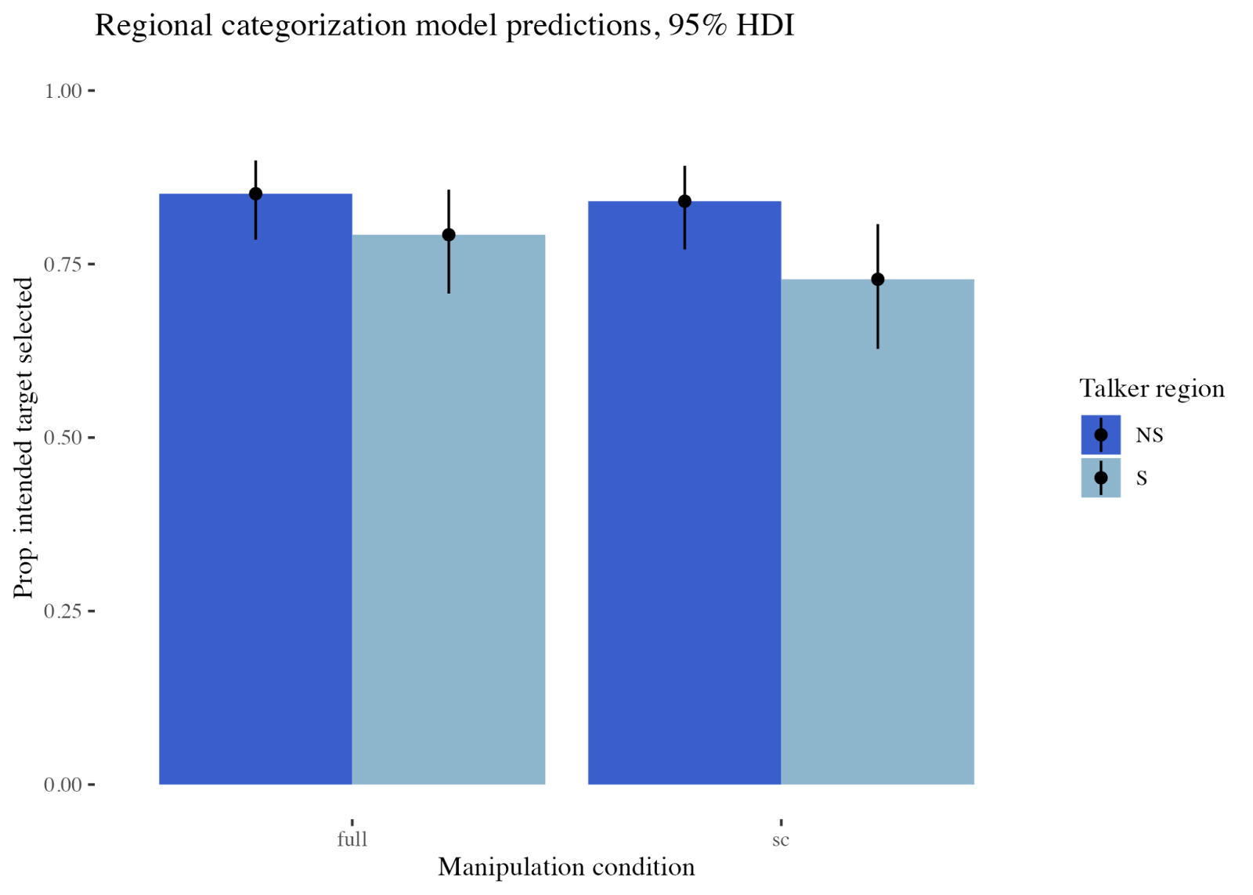
identify which item of a minimal pair they were hearing. In a Social block, participants were asked to identify, using a pair of maps, whether the talker was from the northern or southern US.
Responses to the linguistic trials successfully replicated Strange et al. (1983); full vowel /bVt/ words were perceived with 86.5% accuracy and silent centers (SC) with 84.2% accuracy. Figure 1 shows model predictions for the Social information task. These data are inconsistent with a model of perception in which vowel centers are essential to listeners’ ability to perceive regional
variation. Listeners were almost as accurate at perceiving region as word (c.f. Campbell-Kibler, 2025; Milroy & McClenaghan, 1977) although Southern talkers were identified less accurately. Work is ongoing, but there are potential implications for speech perception theory and for sociolinguistics’ strong focus on vowel centers as units of social meaning. Perhaps, particularly given the deep roots of sociolinguistics in the study of sound change, a more fitting model for vowel perception can be found in the work of Beddor (2009) who proposes a coarticulatory path to sound change which may, from a synchronic perspective, be coarticulatory paths to social meaning (Harrington et al., 2012).

References
Andruski, J.E., Nearey, T.M. (1992). On the sufficiency of compound target specification of isolated vowels and vowels in /bVb/syllables. J. Acoust. Soc. Am. 91, 390–410.
Beddor, P. S. (2009). A Coarticulatory Path to Sound Change. Language, 85(4), 785–821.
Campbell-Kibler, K. (2025). Place-Based Accentedness Ratings Do Not Predict Sensitivity to Regional Features. Journal of Sociolinguistics, 29(1), 74-92.
Fruehwald, J. (to appear). Vowel Formant Track Normalization Using Discrete Cosine Transform Coefficients [Manuscript].
Hall-Lew, L., Cardoso, A., & Davies, E. (2021). Social meaning and sound change. Social Meaning and Linguistic Variation: Theorizing the Third Wave, 27–53.
Harrington, J., Solé, M., Recasens, D., 2012. The coarticulatory basis of diachronic high back vowel fronting. The Initiation of Sound Change 103–122.
Labov, W. (1994). Principles of linguistic change: Internal factors. Wiley-Blackwell.
Lieberman, P., & Blumstein, S. E. (1988). Speech physiology, speech perception, and acoustic phonetics
Cambridge University Press.
Mendoza-Denton, N. (2008). Homegirls: Language and Cultural Practice Among Latina Youth Gangs (1st ed.). Wiley-Blackwell. https://doi.org/10.1002/9780470693728
Mengesha, Z. (2022). A social meaning perspective on vowel trajectories: The FEEL-FILL merger among African Americans.
Milroy, L., & McClenaghan, P. (1977). Stereotyped reactions to four educated accents in Ulster. Belfast Working Papers in Language and Linguistics, 2(4), 1–11.
Murphy, W. D., Shea, S. L., & Aslin, R. N. (1989). Identification of vowels in “vowelless” syllables by 3-year-olds. Perception & Psychophysics, 46(4), 375–383.
Peirce, J. W., Gray, J. R., Simpson, S., MacAskill, M. R., Höchenberger, R., Sogo, H., Kastman, E., Lindeløv, J. (2019). PsychoPy2: experiments in behavior made easy. Behavior Research Methods. 10.3758/s13428-018-01193-y
Strange, W., Jenkins, J.J., 2013. Dynamic Specification of Coarticulated Vowels, in: Morrison, G.S., Assmann, P.F. (Eds.), Vowel Inherent Spectral Change. Springer Berlin Heidelberg, Berlin, Heidelberg,
pp. 87–115.
Strange, W., Jenkins, J.J., Johnson, T.L., 1983. Dynamic specification of coarticulated vowels. J. Acoust.
Soc. Am 74.
Van Engen, K. J., Baese-Berk, M., Baker, R. E., Choi, A., Kim, M., & Bradlow, A. R. (2010). The Wildcat Corpus of native-and foreign-accented English: Communicative efficiency across conversational dyads with varying language alignment profiles. Language and speech, 53(4), 510-540.

6

Two processes or two forms? Accounting for ambiguous tone spreading in Prinmi
Connor Bechler, Michigan State University; bechler4@msu.edu

Prinmi is a Qiangic Sino-Tibetan language spoken in Southwestern China that possesses a system of lexically contrastive tones with a range of tone sandhi patterns. This presentation aims to provide a unified account of Prinmi rightward tone spreading, ̌comparing two closely related varieties of the language, Wa dū Pu mi (Daudey, 2014) and ̌Xīnyíngpán Pu mi (Ding, 2014), hereafter referred to as WDP and XYP.

Prinmi tone spreading involves what appear to be two separate phonological processes: contour spreading (CS) and high tone spreading (HTS). In CS (bolded in ex. 1, 2b, and 3), contour tones on non-tone group final syllables split into their level tone components. In HTS (underlined in ex. 2a and 2b), non-tone group final high tones, either underlying or derived from CS, spread onto one additional syllable. However, XYP also possesses words with mono-syllabic rising tones that display CS but do not undergo HTS even when additional syllables are present in the tone group (ex. 3).

Example Tone Name σ σ.σ σ.σ.σ σ.σ.σ.σ
1 Falling (F) σF σH.σL σH.σL.σL σH.σL.σL.σL
2a High (H) σH σH.σH σH.σH.σL σH.σH.σL.σL
2b Rising & Spreading (R+S) σR σL.σH σL.σH.σH σL.σH.σH.σL
3 Just Rising (J-R, XYP only) σR σL.σH σL.σH.σL σL.σH.σL.σL

While some of the XYP Just Rising (J-R) tone words belong to the same class of verb, a number are common nouns that don’t share any apparent morphological features. This implies that the tone of these words must be underlyingly distinct from the Rising and Spreading (R+S) tone words that exhibit HTS so a process could selectively motivate one to spread but not the other. Ding (2014) posits that tone in XYP is underlyingly composed of two features: syllabic position on the root and a [+/-spread] feature. While descriptive, this analysis is not explanatory or satisfying, mixing autosegmental and featural mechanisms.
Another approach is positing that the J-R tone’s underlying representation (UR) is LHL, with the final L preventing HTS from taking place. However, this requires a more complex process (in terms of either constraints or rule sets) to asymmetrically prevent falling contours from surfacing when derived from CS but not prevent falling contours from surfacing on monosyllables (i.e., somehow coercing σL.σF → σL.σH, but not σF → σH/ σL).

Alternatively, HTS may not be a separate process, but instead a consequence of more complex R+S and H tone URs. If the H tone was underlyingly HH and the R+S tone was underlyingly LHH, CS could directly account for the surface HTS patterns. While the proposed double-high UR superficially violates the OCP, this seems preferable to employing idiosyncratic and asymmetric restrictions on the otherwise predictable contour spreading process, particularly given that adjacent level H tones do not always trigger OCP violations in Sino-Tibetan languages (Tianjin Mandarin, c.f. Chen, 2000; Yu, c.f. Jia, 2021).

7 On the representation of high vowels in Norwegian: Interpreting the results of an
articulatory study
Malgorzata Cavar and Przemysław Pawelec
Norwegian, with its three-way frontness distinction in high vowels, is often invoked as an argument for two features describing the frontness distinction, [± back] and additionally [± front] (Hayes 2009:81). In the system with vowels commonly transcribed as /y, y:, ʉ, ʉ:, u, u:/, the central vowels /ʉ, ʉ:/ do not contrast with true back vowels in [± round], justifying the use of additional [± front].
The vowels transcribed as /ʉ, ʉ:/ have usually been assumed to be central or advanced central (Kristoffersen 2000:14, and references therein). However, Endresen (1991:112) interprets them as phonetically front, slightly centralized in comparison to [y/y:]. Kristoffersen (2000:33) assumes that phonologically /ʉ, ʉ:/ are Dorsal [- back], unlike /y, y:/, which are Coronal, and /u, u:/, which are Dorsal [+ back]. Yet another analysis has been proposed in literature, in particular, utilizing the degree of lip rounding as the distinctive feature. Vanvik (1972:127) describes the lip rounding in /ʉ, ʉ:/ as identical to /u, u:/, while the lips in /y, y:/ are more protruded and further apart. Similarly, Endresen assumes that /ʉ/ and /ʉ:/ have the same degree of rounding as the cardinal /y/ but the Norwegian /y, y:/ is less rounded.
In this paper we report the results of an ultrasound study of Norwegian vowels and propose an alternative analysis. We have collected data from 5 native speakers of Norwegian, originally from the area of Oslo. For the data analysis, we have extracted the location of the mid-tongue root point and a mid-dorsum point using DeepLabCut plug-in for AAA (2019), Articulate Instruments software. The z-score normalized values were then analyzed using linear
mixed–effects models with speaker as a random factor. While /ʉ:/ is usually a little lower than /i:/ and /y/, cf. Fig. 1, the left column, representing individual articulations and Fig.2A (mean values), the front-back position of the dorsum does not differ significantly for long vowels /i:, y:, ʉ:/. The dorsum in /u:/ is significantly retracted when compared to /i:, y:, ʉ:/. This confirms the earlier findings that /ʉ:/ is a front vowel. /ʉ:/ is significantly different from /i:, y:/ in terms of the advancement of the tongue root. The results indicate that /ʉ:/ may be interpreted as a front vowel articulated with a relative retraction of the tongue root. In short vowels too, /u/ is visibly different from all the other high vowels, cf. Fig. 2B and Fig. 1, the right column. While short /i/ and /y/ differ a little in height (the difference is significant), they are otherwise very similar. /ʉ/ lies between /i,y/ and /u/ on the frontness axis – both the dorsum and the tongue root. The dorsum in
/ʉ/ is also relatively lowered as compared to other high vowels, which is a typical effect of the tongue root retraction.
Under the proposed analysis in terms of feature [± ATR] we do not need to introduce [± front] as the second frontness feature. We also do not have to introduce any features referring to the level of lip rounding or their protrusion – instead, we utilize the feature which is already
well-established in the phonological theory.

Articulate Instruments Ltd (2019). “Articulate Assistant Advanced ultrasound module user 683 manual, revision 2.18”.
Endresen, R.T. (1991) Fonetikk og fonologi. Oslo: Universitetsforlaget. Hayes, B. (2009) Introductory phonology. UK: Wiley-Blackwell Publication.
Kristoffersen, G. (2000) The Phonology of Norwegian. Oxford: Oxford University Press. Vanvik, A. (1972) “A phonetic–phonemic analysis of Standard Eastern Norwegian. Part I.” NTS 26: 119–64.
Fig. 1: Tongue shape of high vowels in Speakers 1-5 (individual articulations)
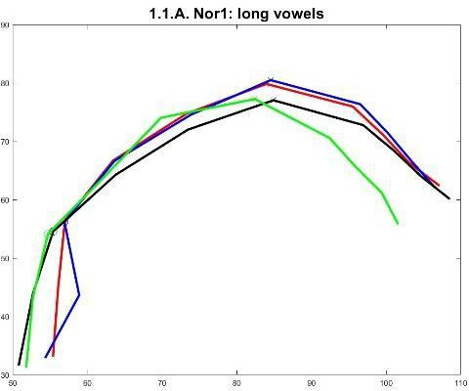
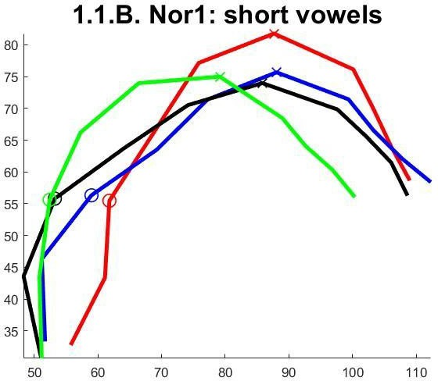

90 r--.--�1_._2._A_.�N_o_r2_: l�o_n�g_v_o�w_e_l_s� ,
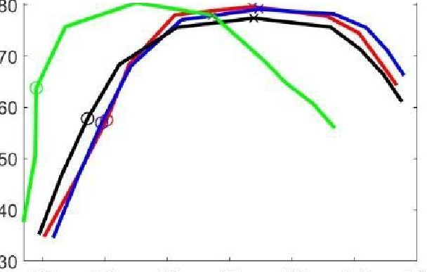
60 70 80 90 100 110 120

1.3.A. �orJ: long vowels
.. 1.2.B. Nor2: short vowels

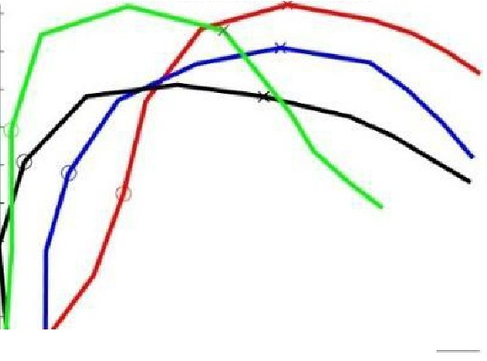
70
60 ro ..
"'
100
110
"
..
..
,.
§
.,
y
40
u
0

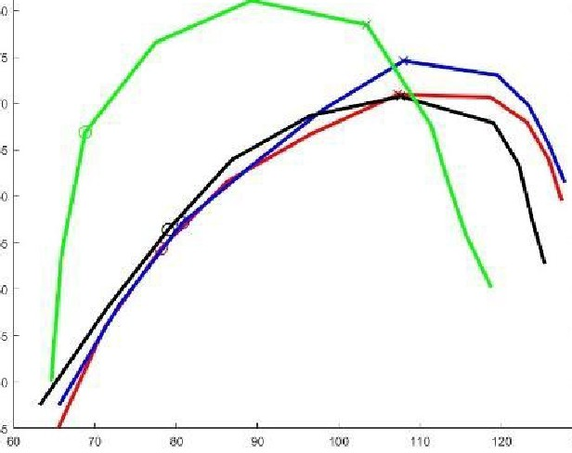
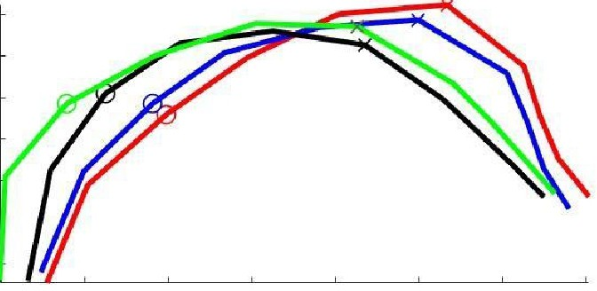
1.3.B. Nor3: short vowels
70
65
60
55
50
45
40
60 70 80 90 100 110 120 130

1.4.A. Nor4: long vowels
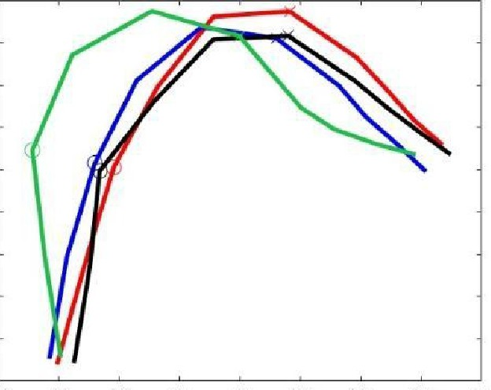
75

70

65

60

56

50

45

40

35

1.4.B. Nor4: short vowels
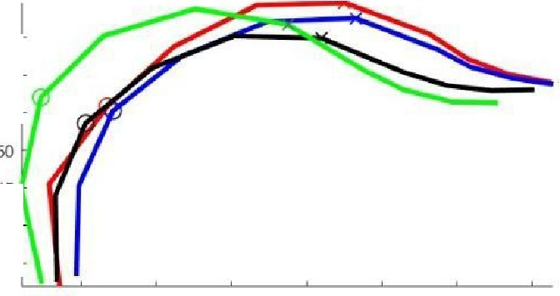
65
60
55
45
40
35
80 70 80 90 100 110 120

30
50 60 70 80 90 100 110 120 130

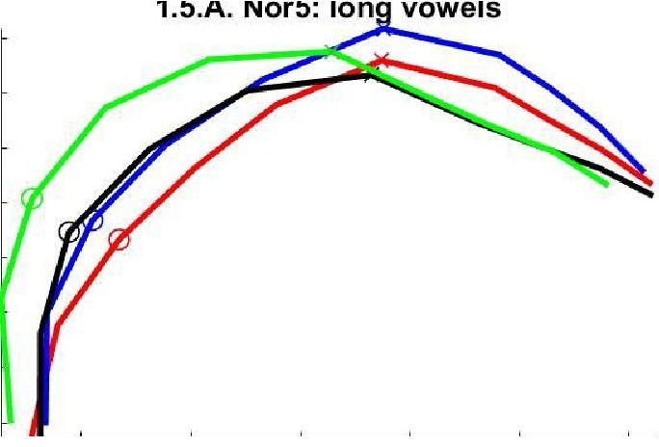
70

65

60

55

50

45

40

35
70 80 90 100 110 120
1.5.B. Nor5: short vowels
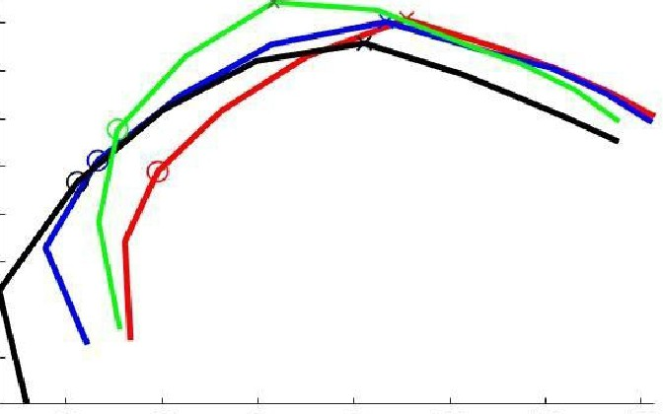
65

60

55

50
45

40

35

30

60 70 80 90 100 110 120

Fig. 2: Mean values, speakers 1-5

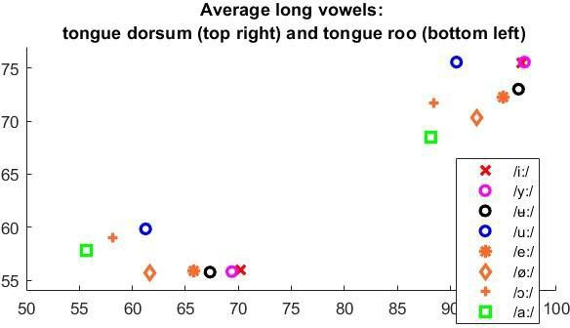
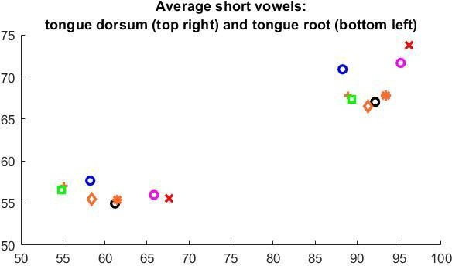

8

Aspiration and its historical sources: Quantifying aspiration in Zuberoan Basque
Mikhael Hayes & José I. Hualde University of Illinois at Urbana-Champaign
Traditionally, a striking dialectal difference that we find in Basque is the high frequency of h and aspirated stops in northern dialects vs. their complete absence in the south. Since a phoneme written h is also found in medieval southern toponyms and in onomastics from Roman times, it is clear that aspiration is a conservative feature in northern Basque. However, not all details of the distribution of aspiration in northern Basque are necessarily reconstructible for Common Basque.
In order to assess the distribution of aspiration from different etymological sources in northern Basque, we have undertaken a study of Larrasquet’s (1939) dictionary of northeastern Zuberoan. We focus on this source because, among modern dialects, Zuberoan appears to be particularly conservative regarding aspiration.
When we analyze aspiration in Larrasquet’s dictionary, the first remarkable fact is that aspiration has an extraordinarily high frequency. Aspiration is found in almost a third of all words in the dictionary (32.7%). In spite of this, it has been long noticed that the distribution of aspiration is subject to two constraints. First, there may be no more than one aspirated segment per word, which Lafon (1935[1999:121]) characterized as a Grassmann’s Law-like constraint. In Larrasquet’s dictionary, we find 50 apparent exceptions to this constraint. All of these are compounds (e.g., ahatzéhi ‘easy to forget’, bethóhil ‘having a fleeing eye’). Secondly, only the first or the second syllable in the word may contain aspiration (Mitxelena 1958, 1977). Mitxelena noticed that in Zuberoan we find a few examples with aspiration beyond the second syllable (e.g. arrathṹ ‘rat’, baranthálla ‘February’). We count 91 exceptions with a single late aspiration, which are again mostly compounds and derived words. We will attempt to account for all exceptions to these two generalizations established by Lafon and Mitxelena.
Going beyond this, other generalizations pertain more narrowly to aspirated stops. We investigate to what extent factors such as the position of the stress in the source language and the age of the borrowing may explain the aspiration or lack of it of stops on the onset of the first or second syllable of the word.Regarding other types of aspiration, we find 148 instances of nasalized laryngeal fricatives, all in intervocalic position on the onset of the second syllable.
Demonstrably in the case of loanwords, /h̃/ derives from the weakening of /n/. In this same position, not counting words with the same root, we find 90 instances of morpheme-internal non- nasalized /h/, where neither of the two flanking vowels is marked as nasalized. We analyze all these items from an etymological perspective in order to determine the relative importance of historical intervocalic /n/-weakening in the development of aspiration.
Finally, word-initial /h/ is very frequent (n = 586), to the extent that some authors have suspected non-etymological aspiration (Trask 1997: 158-159), but there are many more words starting with a vowel (n= 1911). With this detailed analysis of aspiration in Larrasquet’s dictionary, we hope to contribute to a better understanding of the historical causes for the restrictions that we find in the distribution of aspiration and the reasons that explain exceptions to the rules.

References
Lafon, R. 1958.Contribution a l’étude du parler basque de Larrau (Haute-Soule). Repr.,1999, Vasconiana (= Iker 11). Bilbao: Euskaltzaindia, 113-133., Larrasquet, J. 1939. Le basque de la Basse-Soule Orientale. Paris: Soc Ling Paris. Mitxelena, K. 1977. Fonética histórica vasca, 2nd ed. Donostia-San Sebastián: Dip. Foral de Gipuzkoa. Trask, R. L. 1997. The history of Basque. London: Routledge.

9
The L2 phonolexical encoding of Japanese consonantal length: A replication Jeff Holliday1, Jocelyn Brown2, Rachel Kook3, Somin Park4, Gus Thompson5 1,3,4,5University of Kansas; 2University of Kentucky
1jjh@ku.edu, 2jocelynbrown@uky.edu, 3kookrh@ku.edu, 4smpark117@ku.edu, 5thompsonh@ku.edu

Second language (L2) lexical access to words that rely on a difficult contrast may be asymmetric: one member of the pair is more easily recognized than the other. Darcy, Daidone, and Kojima (2013) suggested that this asymmetry was not due to poor phonetic categorization, but rather inaccurate phonolexical encoding. They showed that L1 English L2 learners of Japanese who accurately discriminated between Japanese singleton and geminate consonants in non-words and were also reasonably accurate in recognizing real words containing singleton consonants still struggled to reject non-words containing a singleton consonant whose real word counterpart contains a geminate consonant.
Here, we carried out a replication of Darcy et al. (2013). The subjects were L1 English L2 learners of Japanese (novice n = 8, intermediate n = 5, advanced n = 10). Subjects completed two tasks: (1) auditory ABX non-word discrimination of Japanese consonant length (test trials) and vowel quality (control trials), and (2) auditory lexical decision on Japanese real words containing a singleton or geminate consonant, corresponding non-words created by changing the target consonant to either a geminate or singleton, ﬁller real words, and corresponding ﬁller non-words created by changing a segment but not consonant length.
Results from the ABX discrimination showed that L2 learners can reliably distinguish between Japanese singleton and geminate consonants, with mean accuracy over 90% for all three learner groups on both control and test trials. On lexical decision, all three groups were more accurate on ﬁller (81.3%) than target trials (65.6%), showing that overall listeners had lexically encoded consonant length less accurately than other consonant and vowel contrasts. Lexicality had little effect on ﬁller trials, but on test trials subjects had a much harder time rejecting non-words than accepting real words, especially when the non-word contained a singleton consonant. That is, real words containing geminates (gem-RW) are accurately recognized, but if the geminate is changed into a singleton and becomes a non- word (sing-NW), learners often fail to reject it. Geminate non-words formed from singleton real words (gem-NW), however, are more easily rejected. These results overall conﬁrm the ﬁndings of Darcy et al. (2013). Testing of L1 Japanese listeners is ongoing.

Lexical  Decision | Filler trials |  | Target trials (consonant length)
Lexical  Decision | RW | NW | sing-RW | gem-RW | sing-NW | gem-NW
Novice | 74.2 | 73.0 | 82.2 | 63.3 | 40.6 | 51.9
Intermediate | 85.7 | 85.4 | 90.0 | 86.2 | 26.2 | 64.6
Advanced | 89.0 | 81.6 | 92.7 | 88.8 | 24.4 | 55.5

10

Pitch is Fundamental: Has Congressional Rhetoric Become More Polarized?
Yi-Fang Cheng, Purdue University (cheng627@purdue.edu)

Past studies have shown a general trend of increasing polarization in the United States Congress (Ballard et al., 2022; Neal, 2020, among others). While an extensive body of study has leveraged text data to examine rhetoric polarization (Ballard et al., 2023; Correia et al., 2016; Russell, 2018), little has explored this phenomenon using audio data. Yet, audio data can be informative in two ways. Firstly, due to its presence of non-lexical paralinguistic features, such as pitch, audio data offers a unique window to investigate speakers’ emotion status, given that emotions are encoded in pitch variations. Secondly, since pitch affects human perception, politicians might manipulate their speech behavior through media to influence audience perception.

The current study utilized the C-SPAN archive data to analyze the 2016 US presidential rally speeches of the two candidates from the two major parties–Trump and Clinton. The fundamental frequency (F0) of audio data segments where the opponent was mentioned was compared with baseline segments discussing general topics. The primary tools for audio analysis included the linguistic software, Praat, and several Python libraries. The preliminary results showed that Trump displayed greater emotional intensity when mentioning his opponent (see Figure 1). These findings shed light on the potential influence of journalism on how politicians control their speech to sway audience perceptions, potentially contributing to polarization. Building on the established link between vocal pitch, emotional intensity, and political speech dynamics (Dietrich et al., 2019), this research highlights the novel audio-based approach by utilizing pitch as an instrument to uncover the embedded emotional cues to explore political rhetoric polarization. The current study seeks to add to the existing body of polarization research through a new dimensional analysis and discusses how linguistic features can be useful in examining polarization from a journalism perspective.

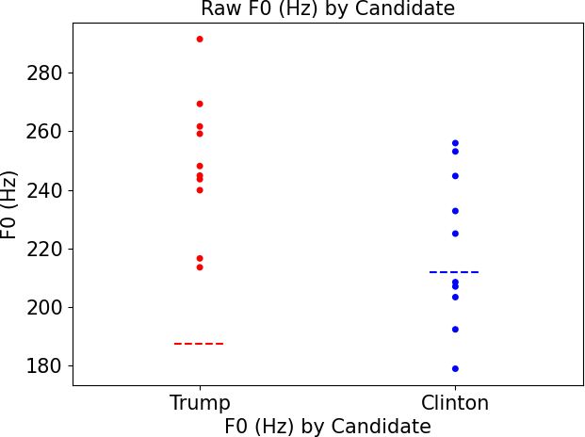
Figure 1. Raw frequency by candidate. The dashed lines represent baseline values.

References
Ballard, A. O., DeTamble, R., Dorsey, S., Heseltine, M., & Johnson, M. (2023). Dynamics of polarizing rhetoric in congressional tweets. Legislative Studies Quarterly, 48(1), 105–144.
Ballard, A., DeTamble, R., Dorsey, S., Heseltine, M., & Johnson, M. (2022). Incivility in Congressional Tweets. American Politics Research, 50(6), 769–780.
Correia, R. B., Chan, K. N., & Rocha, L. M. (2016). Polarization in the US Congress. In Annual Conference of the Comparative Agendas Project, CAP 2015.
Dietrich, B. J., Hayes, M., & O'Brien, D. Z. (2019). Pitch Perfect: Vocal Pitch and the Emotional Intensity of Congressional Speech. American Political Science Review, 113(4), 941–962.
Neal, Z. P. (2020). A sign of the times? Weak and strong polarization in the US Congress, 1973– 2016. Social networks, 60, 103–112.
Russell, A. (2018). US senators on Twitter: Asymmetric party rhetoric in 140 characters. American Politics Research, 46(4), 695–723.

Poster session 2 abstracts

11 Comparing implicit phonological knowledge of humans and LLMs
Anne Pycha, University of Wisconsin, Milwaukee, pycha@uwm.edu
Although trained exclusively on text, large language models (LLMs) perform reasonably
well on explicit phonological tasks such as syllable-counting and rhyme generation (Suvarna et al., 2024). But true phonological knowledge often operates implicitly. For example, when humans hear words that are phonological neighbors, such as fat, that, cab, etc., they are likely to generate a memory of cat (Sommers & Lewis, 1999). While this memory is technically “false,” it nevertheless reflects an internal organization in which similar-sounding words are associated to one another (Gallo, 2006). Probing LLMs for this type of knowledge is important because, in the syntactic domain, LLMs “have mastered many aspects of linguistic form” (Potts, 2024), including implicit tasks such as long-distance agreement and anaphora, creating a strong illusion of human language competence. Moving beyond syntax to test LLMs on implicit knowledge of phonology will help us to gauge the extent to which this illusion is – or is not – complete.
We pursued this goal by comparing human and LLM performance on the Deese-Roediger- McDermott paradigm (DRM) (Deese, 1959; Roediger & McDermott, 1995), in which lists of words are presented at study and subsequently probed at test. The words on each study list are all associated to a critical item, which is not presented. For example, fat, that, cab, caught, cot, sat, cut, hat, kit, vat, cap, mat, bat, cad, chat, are all neighbors of the critical item cat. At test, words are presented individually, and the task is to give a yes/no response indicating whether the word occurred at study. With humans, Sommers and Lewis (1999) have reported a recognition rate of 64% for critical items such as cat, significantly higher than baseline intrusions. Dozens of other DRM studies have reported similar results (Gallo, 2006, 2010).
We replicated the study of Sommers and Lewis (1999) with human participants (n=30) and with OpenAI’s ChatGPT 4o (n=30 prompting sessions). For comparison, a smaller amount of data was collected from Anthropic’s Claude 3.7 Sonnet. Study stimuli consisted of 24 lists of fifteen words. On each list, all words were phonological neighbors of a single CVC critical item, where “neighbor” is a word that differs by addition, deletion, or substitution of a phoneme. The twenty- four lists of were divided into three groups of eight lists each; each human participant, or each prompting session with an LLM, was randomly assigned to a group. Test stimuli consisted of twenty-four veridical (presented) items (e.g., fat), eight critical items (e.g., cat), and thirty-two intrusion (non-presented) items (e.g., wide). Stimuli for humans were recorded and played auditorily; stimuli for LLMs were entered as text, with the instruction to “act like a human listening to each word spoken out loud.”
Descriptive results, displayed as proportion of “yes” responses, differ for humans and LLMs across all item types. As expected, humans exhibited (false) recognition for critical items at a rate significantly higher than for intrusions (� = 1.52, std. error = 0.17, z = 8.75, p < 0.001). By contrast, ChatGPT 4o exhibited no recognition of critical items at all (neither did Claude 3.7).

Veridical Critical item Intrusion

Human 0.61 (0.16) 0.67 (0.20) 0.27 (0.16)
ChatGPT 4o 1.00 (0.00) 0.00 (0.06) 0.08 (0.27)
Sommers & Lewis (1999) 0.75 0.64 0.18
We conclude that LLMs do not exhibit implicit knowledge of associations between similar- sounding words. Thus, even if LLMs are able to generate rhymes when queried explicitly (Suvarna et al., 2024), they otherwise behave as if words like fat, that, cab are unrelated – a behavior that is clearly inconsistent with the language competence of humans.

12 Down → dong: a case of feature spreading and loss in Belize Kriol

Jarod Warner, Indiana University, jacwarne@iu.edu

This paper examines the development of the rhyme [oŋ] in Belize Kriol (BK), an English-lexifier creole, in lexical items corresponding to English words with [aʊn]. In BK, words such as dong ‘down’, brong ‘brown’, and rong ‘round’ consistently show [oŋ] where English has [aʊn].
Although [ŋ] can follow other vowels in BK and [o] can appear with [n], the [oŋ] sequence occurs only in words historically containing English [aʊn]. This distribution suggests a targeted phonological restructuring rather than a general sound change.
Previous accounts, such as Decker (2009), propose that English [aʊn] first undergoes
nasal assimilation to the vowel Place [Dorsal] ([n] → [ŋ]), followed by diphthong reduction ([aʊ]
→ [o]). While acknowledging possible historical motivations, this paper rejects a sequential rule- based derivation and instead develops a representational and constraint-based analysis. Drawing on work in Jamaican Creole (Cassidy & Le Page 1980; Lalla & D’Costa 1990; Beckford- Wassink 2001) as well as BK (Escure 1981; Greene 1999; Decker 2009), I argue that the diphthong in question is underlyingly /ou/ rather than /au/, consistent with the shared lexifier and substrate history of BK and JC.
Using the framework of feature geometry, I propose that the [oŋ] outcome arises when
Dorsal and its features [+high, -low, +back] from the less prominent element of the diphthong,
/u/, spread to the following nasal /n/, while the same features are lost from the less prominent target of the diphthong itself. The more prominent element, /o/, is retained, yielding [oŋ]. No other vowel spreads its features to the nasal.
Long [u:] does not occur with final [ŋ] but does with final [n] evidenced by soon [su:n] ‘soon’ and choon [tʃu:n] ‘tune’. Short [u] does not appear in a rhyme with any nasal. I propose that only the high back target of the diphthong spreads its Dorsal features [+high, -low, +back] to the nasal. Diphthongal [u], being of lower prominence than [o], lends its Dorsal features to the nasal and its features are removed from the nucleus. In a sense, [u] and [n] collapse into [ŋ]. The nature of why this should be is to be determined.
In addition to looking through the lens of feature geometry, I present the analysis within Optimality Theory (McCarthy & Prince 1993, 1995; Prince & Smolensky 2004). The shift from [oun] to [oŋ] involves both feature change for the nucleus and the coda as well as retention of a [+HIGH] feature in the rhyme, which I analyze as the result of ranked markedness and faithfulness constraints. If we grant a constraint *uN]σ (no non-long [u]+[nasal] rhyme) and MAX([+HIGH]) (the number of segments in the output with the feature [+high] must be no fewer than in the input), we see the following ranking of constraints: *uN]σ, IDENT([NASAL]), MAX, MAX([+HIGH]) ≫ IDENT([+HIGH]). All the constraints to the left of IDENT([+HIGH]) are more fatal violations than IDENT([+HIGH]), which will eliminate [doŋ] because the nucleus has lost its [u] target with the [+high] feature.
Feature geometry accounts for the representational mechanisms behind feature spreading, while OT provides the evaluative system that determines the optimal output. Together, these frameworks, combined with diachronic considerations, offer a principled account of why BK diverges from its lexifier in this specific environment. This study contributes to our
understanding of creole phonology by showing how BK’s sound system reflects both systematic constraint interaction and historical restructuring, rather than simple reduction of the English lexifier.

13 Development of a Speech Rhythm Modula5on Detec5on Task
Milad Youseﬁ, Department of Speech and Hearing Science, University of Illinois Urbana- Champaign, Champaign, Illinois, USA – milady2@illinois.edu
Daniel Fogerty, Department of Speech and Hearing Science, University of Illinois Urbana- Champaign, Champaign, Illinois, USA – dfogerty@illinois.edu

Abstract
Speech rhythm is characterized by slow amplitude modulations (<16 Hz) that are crucial for the perception of prosody and stress, as well as for speech intelligibility. The ability of a listener to detect these speech amplitude modulations is important for speech perception. However, standard psychoacoustic tests of modulation detection typically use simple sinusoidal modulators instead of the complex envelopes of real speech, which may limit the ecological validity of such laboratory tests. This study introduced a novel speech-derived envelope approach to measure modulation detection thresholds for two frequency bands. Twenty young adult listeners with normal hearing (ages 18–30) participated in a three- interval, two-alternative forced-choice task to identify which 500-ms speech-shaped noise burst was amplitude-modulated by a speech envelope (vs. an unmodulated burst). The noise stimuli were ﬁltered into two one-third-octave bands: a lower frequency band centered at 500 Hz and a higher frequency band at 3150 Hz. On each trial, only one band carried the speech-derived modulation while the other band remained steady, isolating detection in that spectral region without across-band interference. An adaptive tracking procedure called Parameter Estimation by Sequential Testing (PEST) adjusted the modulation depth to estimate the 50% modulation detection threshold for each band.
Results showed that modulation detection was signiﬁcantly better at 3150 Hz than at 500 Hz, with listeners able to accommodate greater compression of the amplitude modulation in that band. A paired-sample t-test conﬁrmed that this diZerence was statistically signiﬁcant (p = 0.01) with a moderate eZect size (Cohen’s d ≈ 0.66). This potentially indicates greater sensitivity to speech envelope cues at higher frequencies, possibly reﬂecting the prominence of consonant-related modulations in that region. By using natural speech envelopes instead of synthetic modulators, this paradigm provides a more realistic measure of speech temporal processing across frequency bands. This method shows promise for future research and clinical applications. For example, in examining how aging or hearing loss may aZect the perception of speech rhythm across diZerent frequency regions. [Work supported by NIH/NIDCD].

Prosody and social meaning: Intonational marking of politeness in Mexican Spanish Bruno Staszkiewicz
14
Indiana University bstaszki@iu.edu

Prosody plays a key role in expressing social meaning, a link recognized by the Frequency Code (Ohala, 1984) and Politeness Theory (Brown & Levinson, 1987). Cross-linguistic studies have shown that suprasegmental features signal politeness in languages such as Korean (Brown et al., 2014) and Catalan (Hübscher et al., 2017). Yet few studies have examined how pragmatic variables—power, distance, and imposition—affect prosody, and none have modeled F0 contours in relation to politeness.
This study investigates how Mexican Spanish speakers use intonation to encode politeness in polar questions, focusing on how contours vary with power, social distance, and imposition. Twenty-five native speakers (17 female, 8 male; M= 24.4 years, SD = 6.71) from Guadalajara and Guanajuato completed a contextualized sentence-reading task. Sixteen paragraph-length scenarios, systematically manipulated for power, distance, and imposition, were followed by 8- syllable polar questions (e.g., ¿me puedes tirar la bola?). Each condition was repeated three times, producing 1,200 utterances (1,177 analyzed). F0 was extracted at 80 points per sentence and normalized into z-scores. Pitch contours were modeled using generalized additive models (GAMs). Results revealed significant effects of all three pragmatic variables: power (F = 1154– 1250, p < .001), distance (F = 1180–1233, p < .001), and imposition (F = 1164–1236, p < .001). Figures 1–3 illustrate how contours diverge over time across conditions.
Findings show that Mexican Spanish speakers systematically modulate intonation in response to power, distance, and imposition, highlighting prosody’s role in encoding social meaning. These results extend prior work by showing that nuanced prosodic modulation reflects contextual factors of politeness, situating Mexican Spanish within broader cross-linguistic patterns and contributing to the interface between pragmatics and intonation.
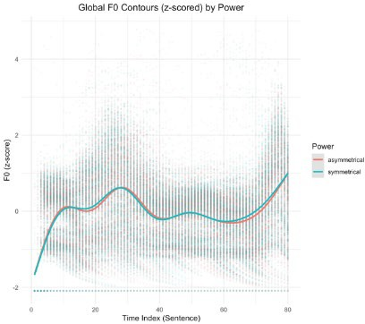
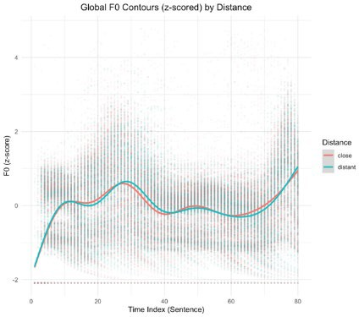
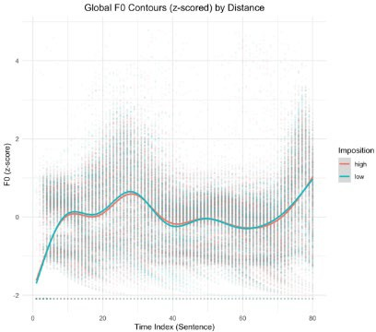
Figure 1. GAM for power Figure 2. GAM for Distance Figure 3. GAM for Imposition
Selected References
Brown, P., & Levinson, S. C. (1987). Politeness: Some universals in language usage (Vol. 4). Cambridge University Press.
Brown, L., Winter, B., Idemaru, K., & Grawunder, S. (2014). Phonetics and politeness: Perceiving Korean honorific and non-honorific speech through phonetic cues. Journal of Pragmatics, 66, 45–60.
Hübscher, I., Borràs-Comes, J., & Prieto, P. (2017). Prosodic mitigation characterizes Catalan formal speech: The Frequency Code reassessed. Journal of Phonetics, 65, 145–159.
Ohala, J. J. (1984). An ethological perspective on common cross-language utilization of F0 of voice. Phonetica, 41(1), 1–16.

15 Exploring the Northern Cities Shift of Korean Americans in Chicago
Wooji Park (wjinpark@iu.edu) Indiana University, Bloomington

The Northern Cities Shift (the NCS, Figure 1) is a subsequent vowel shift in which the positions of /ɪ, ɛ, æ, ʌ, ɔ, ɑ/ change and relocate accordingly in Inland Northern dialect regions of North American English (Labov et al., 2006). One of the well-studies in this phenomenon is the raising and fronting of /æ/, contributing to the distinct accent characteristics of the Inland North dialects. Interestingly, recent studies have reported the reversal of the NCS in younger speakers’ speech production in the areas such as Syracuse, New York and Lansing, Michigan (Driscoll & Lape, 2015; Nesbitt, 2021b), as the NCS accents invoke the negative images that the speaker having them is uneducated or using incorrect English (e.g., Nesbitt, 2021a). In contrast to the NCS recession, it has also been observed that some younger speakers still show NCS-like features in “perception”. For example, younger speakers in Chicago exhibit a phonemic category boundary of hɛd (head) – hæd (had) in the earlier step between the 3rd and 4th step among 8-step continua, where clear /ɛ/ is in the 1st step and clear /æ/ is in the 8th step while the sounds between the 3rd and 6th step are confusing to decide whether they are /ɛ/ or /æ/. Older speakers in Chicago, however, show a phonemic category boundary between the 7th and 8th step (D’Onofrio, 2021).
These findings raise the following question: “Do heritage language speakers also participate in the local changes in sound perception despite significant amounts of exposure to the heritage language? To answer this, I focused on second-generation Korean Americans in Chicago and their /ɛ/-/æ/ perception of English to determine whether they exhibit the NCS-features, although exposed to heritage language (Korean) where /ɛ/ and /æ/ are not contrastive.
The data was collected from 7 participants: 2 young native English speakers in Chicago, 2 second-generation Korean Americans in Chicago, 2 young native English speakers in Southern Indiana, where the shift does not operate, and 1 young monolingual Korean. They performed a two-alternative forced choice vowel categorization task. The purpose of this task is to pinpoint a phoneme category boundary between English /ɛ/ and /æ/. In the task, they heard the words BEG and SET with clear /ɛ/ (Sound A), BAG and SAT with clear /æ/ (Sound B), and one sound among the 21 BET-BAT continua (Sound X) sequentially. Then, they were asked to categorize the third sound X as either Sound A or Sound B category. As for the results (Figure 2), it was revealed that the cross-over points of both young native English speakers in Chicago and Korean Americans in Chicago are formed near the 13th step, whereas those of speakers in Southern Indiana approximate the 16th. Yet, the monolingual Korean participant fails to create a clear phoneme boundary between /ɛ/ and /æ/ within 21-step continua. Logistic Regression Estimates confirm these results (Table 1); a phoneme category boundary between /ɛ/ and /æ/ among the Korean American participants in Chicago is 12.8, and that of the native English participants in Chicago is 13.3. On the contrary, the participants in Southern Indiana exhibit the boundary at 16.0, and the monolingual Korean participant indicates the boundary at 45.4 beyond the study’s scope.
Taken together, these findings suggest that the Korean American participants in Chicago have a clear phoneme boundary between /ɛ/ and /æ/, unlike the monolingual Korean speaker, meaning that their heritage language (Korean) has little or no impact on their perception of English /ɛ/ and /æ/. More importantly, it also signifies that they participate in local sound changes in perception by perceiving /æ/ as more fronted and raised in the similar way native English participants in Chicago do in the same age group. Future research could explore this study’s topic by expanding speakers’ heritage status (the 1st and 1.5 generation), gender, and different attitudes toward heritage language use and culture.

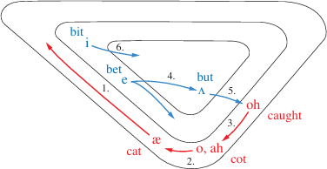

Figure 1. The Northern Cities Shift (Labov et al., 2006)

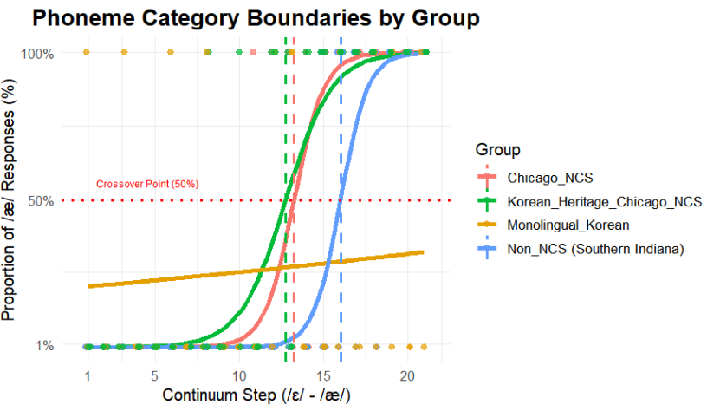

Figure 2. Proportion of /æ/ Responses and Crossover Points by Group

Table 1. Logistic Regression Estimates and Category Boundaries by Group

Participant Group | Intercept | Slope | Boundary
Chicago_NCS | -14.9 | 1.12 | 13.3
Korean_Heritage_Chicago_NCS | -9.32 | 0.731 | 12.8
Non_NCS (Southern Indiana) | -19.7 | 1.23 | 16.0
Monolingual_Korean | -1.38 | 0.0304 | *45.4 (!)

References

Driscoll, A., & Lape, E. (2015). Reversal of the Northern Cities Shift in Syracuse, New York.
University of Pennsylvania Working Papers in Linguistics, 21(2), 41-47.
D’Onofrio, A. (2021). Age-based perceptions of a reversing regional sound change. Journal of Phonetics,86, 101038.
Labov, W., Ash, S., & Boberg, C. (2006).The Atlas of North American English: Phonetics, Phonology and Sound Change. Mouton de Gruyter.
Nesbitt, M. (2021a). From an indicator to a marker: Urban dialect loss in Michigan. In Urban Matters: Current approaches in variationist sociolinguistics (p.159-178). John Benjamins Publishing Company.
Nesbitt, M. (2021b). The rise and fall of the Northern Cities Shift: Social and linguistic reorganization of TRAP in twentieth-century Lansing, Michigan. American Speech: A Quarterly of Linguistic Usage, 96(3), 332-370.

16

Tonal acquisition in a Second Language
Pin-Yu Chen¹ & Isabelle Darcy²
Second Language Studies at Indiana University;¹pinychen@iu.edu; ²idarcy@iu.edu

This study investigates how second language (L2) learners of Mandarin develop categorical
perception of lexical tones over the course of acquisition. English-speaking learners at different proficiency levels were recruited to examine developmental patterns.
L2 learners often struggle with perceiving or producing tones, especially when their first
language (L1) is non-tonal. Prior research has typically focused either on naïve listeners or on L2 learners at a single proficiency level (e.g., intermediate), leaving developmental trajectories
largely unaddressed. Studies of naïve listeners suggest that those from non-tonal L1s may lack categorical perception of tones (Halle et al., 2004), though they can still detect pitch differences (Burnham et al., 2015; Schaefer & Darcy, 2014). Moreover, pitch usage in one’s L1 has been shown to predict sensitivity to tonal contrasts in an L2 (Schaefer & Darcy, 2014). However, findings from L2 learner studies are mixed: some show advantages for tonal L1 speakers
(Wayland & Guion, 2004), while others suggest that L1 background does not reliably predict tone perception outcomes (Laméris et al., 2023).
To address this gap, this study employed a classic categorical perception paradigm using an ABX discrimination task and a two-alternative forced-choice identification (ID) task, alongside a
Chinese lexical decision test (LexTALE-CHI; Wen et al., 2024) to assess proficiency. Stimuli
were synthesized along a 10-step tonal continuum between Mandarin Tone 1 (55, high-level) and Tone 4 (51, high-falling). In the ABX task, participants heard three stimuli (A, B, X), where X
matched either A or B, and A and B were separated by two steps (e.g., step 1 vs. 3). In the ID task, participants saw two words (Chinese character with Pinyin and Zhuyin indicating Tones 1 and 4) and were asked to choose which word matched the auditory stimulus.
To date, 15 participants have been tested, including eight Mandarin L1 speakers and seven
English L2 learners (at beginner, intermediate, and advanced levels). Preliminary results showed that L1 Mandarin speakers exhibited robust categorical perception, with peak sensitivity in the ABX task and sharp transitions in the ID task. Beginners displayed relatively flat response
patterns, consistent with non-categorical perception. In contrast, intermediate and advanced
learners showed increasingly categorical responses, suggesting progressive acquisition of tonal categories.
Logistic mixed-effects modeling revealed significant differences between L1 and L2 groups, with pairwise comparisons confirming group-level distinctions. These findings suggest that categorical perception may initially be absent in learners from non-tonal L1 backgrounds but develops with increased L2 proficiency – a novel finding. Ultimately, advanced learners may approach tonal perception patterns found in L1 Mandarin speakers.
Additional participants of a tonal L1 group (Thai learners of Mandarin) will be recruited to shed light on the initial state of tone perception across L1 backgrounds and to test whether L1 tone categories facilitate or interfere with tone acquisition in L2. Possible mechanisms of categorical perception emergence will be discussed.

17 Does sub-segmental variation affect perception of voiceless nasals?
Grayson Ziegler (grzieg@iu.edu) — Indiana University
Phonemic voiceless nasals in languages of the South-Central branch of Tibeto-Burman
(SCTB) are found to exhibit considerable variation in the timing of glottal and oral gestures (contra descriptions of voiceless nasals in other languages, e.g. Chirkova et al. 2019), resulting in phonetic- level variation ranging from pre-voiced [ⁿn̥] to aspirated [n̥ʰ] (Hoffman 2018; Ziegler et al. 2023; Ziegler 2024). Voiced sub-segments in voiceless nasals are described as contributing crucial acoustic cues to phonemic place or voicing contrasts (e.g., /n̥/–/n/ or /n̥/–/m̥/) (Ohala & Ohala 1993; Silverman 1996), raising the questions of whether non-pre-voiced (i.e., [n̥^{(h)}]) variants of voiceless nasals in SCTB languages are less categorically perceptible than pre-voiced variants. This paper presents a pilot investigation on the effect of variation on the categorical perception of voicing and place contrasts in phonemic voiceless nasals in SCTB languages.
Voiceless nasals are often characterized as multi-phasic due to a temporal offset between two gestures: (1) voicelessness and (2) oral consonantal constriction (Bhaskararao & Ladefoged 1991; Chirkova et al. 2019). This offset can produce segments ranging from post-voiced [n̥ⁿ] (as is common in Burmese) to aspirated [n̥ʰ] or pre-voiced and aspirated [ⁿn̥ʰ] (as are common in Angami) (Bhaskararao & Ladefoged 1991). Ohala & Ohala (1993) argue that voiceless nasals are multi-phasic due to low-intensity noise and lack of spectral shaping in the voiceless closure portion, making voiceless nasals auditorily non-optimal and encouraging offsetting gestures to create a more acoustically salient (voiced) phase. Furthermore, Ohala and Ohala (1993) and Silverman (1996) argue that voiceless closure is poor at encoding formant transitions, encouraging a voiced phase (either pre- or post-voiceless closure) to encode phonemic place of articulation contrasts. However, no perceptual research has been conducted to confirm (a) whether speakers better perceive voiceless nasals with more gestural offset (and therefore a voiced or aspirated phase) or (b) whether a voiced phase aids in the perception of place of articulation contrasts.
Voiceless nasals in SCTB languages tend towards a pre-voiced unaspirated voiceless nasal [ⁿn̥] but can surface as monophasic voiceless [n̥] or aspirated [n̥ʰ], suggesting that a voiced component could be beneficial but not required for perception of place and/or voicing contrasts. To probe whether pre-voiced voiceless nasals facilitate perception more accurately or quickly than true voiceless nasals, the following categorical perception study was designed. 6 speakers (6F, 18- 28) of 4 SCTB languages (1 Lutuv (or Lautu), 1 Falam, 2 Mizo, and 2 Zophei) which all contrast
/m m̥ n n̥/ will participate in an AX categorical discrimination task consisting of two stimuli blocks. Block 1 contains 72 stimuli, 18 of which are voiced-voiceless alveolar nasal pairs /əna/~/ən̥a/ where voiceless sonorants were (a) prevoiced [ⁿn̥], (b) true voiceless [n̥], or (c) prevoiced and aspirated [ⁿn̥ʰ]. Block 2 contains 72 stimuli, 18 of which are bilabial-alveolar nasal pairs
/ən̥a/~/əm̥a/ where both sounds are (a) prevoiced [ⁿm̥-ⁿn̥] or (b) true voiceless [m̥-n̥] with (c) modal [m-n] as a control. Speakers are asked to categorize pairs of stimuli as same or different. Stimuli came from wordlist recordings of 4 male adult Hakha Lai speakers. To prevent phonetic-level categorization, A and X stimuli in each trial were produced by different talkers.
Data collection is ongoing, but preliminary results suggest discrimination of both /n/-/n̥/ and /m̥/-/n̥/ contrasts is only marginally aided by pre-voicing—participant accuracy is near-ceiling in both blocks, but reaction time is faster for pre-voiced nasals (x̄ = 140ms) than true voiceless nasals (x̄ = 167ms). Further piloting is required to determine whether near-ceiling accuracy is due to task-related effects or whether voicing plays a minimal role in speakers’ perception of /n̥/–/n/ and /n̥/–/m̥/ contrasts, contrasting with Ohala & Ohala’s (1993) claims. If so, SCTB speakers may be accommodating rampant free variation by attuning to acoustic cues to contrast (both for voicing and place contrasts) that are not restricted to the voiced sub-segment of voiceless nasals.

References
Bhaskararao, P., & Ladefoged, P. (1991). Two types of voiceless nasals. Journal of the International Phonetic Association, 21(2), 80–88. https://doi.org/10.1017/S0025100300004424
Chirkova, K., Basset, P., & Amelot, A. (2019). Voiceless nasal sounds in three Tibeto-Burman languages. Journal of the International Phonetic Association, 49(1), 1–32. https://doi.org/10.1017/S0025100317000615
Hoffmann, M. E. (2018). Speaking and Being Chin in America: A Linguistic and Anthropological Look at a Refugee Community from Burma (Myanmar) [Doctoral dissertation, The University of Arizona]. https://www.proquest.com/docview/2164266965/abstract/E49457D85889442APQ/1
Ohala, J. J., & Ohala, M. (1993). The phonetics of nasal phonology: Theorems and data. In Nasals, Nasalization, and the Velum (Vol. 5, pp. 225–249). Elsevier. https://doi.org/10.1016/B978-0-12-360380-7.50013-2
Silverman, D. (1996). Voiceless Nasals in Auditory Phonology. Annual Meeting of the Berkeley Linguistics Society, 22(1), 364. https://doi.org/10.3765/bls.v22i1.1357
Ziegler, G. (2024). Acoustic invariablity with high articulatory ability: voiceless sonorants in Hakha Lai. [Conference presentation] MidPhon 29.
Ziegler, G., Berkson, K. & Flego, S. (2023). Variable production of voiceless sonorants in Hakha Lai. 184th Meeting of the Acoustical Society of America. https://doi.org/10.1121/10.0018886

18 High vowel transparency in Eastern Andalusian Spanish vowel harmony
Maialen Casquete (maialen2@illinois.edu), University of Illinois at Urbana-Champaign José Ignacio Hualde (jihuade@illinois.edu), University of Illinois at Urbana-Champaign
Eastern Andalusian Spanish (EAS), a dialect spoken in southern Spain, is characterized by the reduction or loss of most word-final consonants. This consonant deletion triggers laxing of adjacent non-high vowels, which in turn drives vowel harmony: the open quality of the final, lax vowel spreads leftward, typically targeting the stressed syllable (Navarro Tomás, 1939; Rodríguez Castellano & Palacio, 1948; Henriksen, 2017; Herrero de Haro, 2019). High vowels, which do not undergo or trigger laxing, are considered transparent to harmony in words such as cómicos [ˈkɔmikɔ] (Jiménez & Lloret, 2020).
High vowel transparency in EAS challenges the principle of locality, which predicts that non-participating vowels should block harmony from spreading (Archangeli & Pulleyblank, 1994, 2007). Solutions such as bridge or relativized locality (Nevins, 2010; Asahi, 2012; Van der Hulst, 2018) hold that harmony can “skip” intervening incompatible vowels in some cases, such as when the harmonic target is stressed, as described for EAS (Jiménez & Lloret, 2009, 2018; van der Hulst, 2018; Kaplan, 2020). However, in a previous study (currently under revision in JIPA), I found harmony triggered by stressed vowels in EAS (e.g., bebés [bɛˈbɛ] ‘babies’; cf. bebé [beˈbe] ‘baby’). This raises the question of whether high vowels are transparent in words with final stress (pediréis [pɛdiˈɾɛj] ̴ [pedı̇ˈɾɛj]).
For this experiment, I recorded 19 speakers (10F, 9M) of EAS from Granada. I looked at differences in V1 /e/ between words with intervening high vowels such as pediréis (where the final vowel is lax), words with no intervening high vowel such as beberéis ‘you (pl) will drink’ (also lax final vowel), and words with tense /e/ such as bebé ‘baby’. I conducted two linear mixed-effects model regressions (one for F1, inversely correlated with height; one for F2, correlated with frontness). I considered the effect of Condition (Intervening /i/, Non- intervening /i/, Tense). Speaker and Token were included as random factors. The F1 analysis returned no significant difference in V1 between the intervening and non-intervening conditions (p.= .13, Est. 28.51) while /e/ was different between the intervening and tense conditions (p. <.001, Est. -111.7). For F2, V1 in the intervening condition was also not significantly different from the non-intervening (p. .27 Est. -10.4), but it was different from the tense (p.<.005, Est. 95.93). In sum, results show that V1 is realized as lax when there is an intervening high vowel (e.g. [pɛdiˈɾɛj]), suggesting that /i/ acts transparently. I am currently conducting research to confirm whether /i/ remains tense.
Findings showing that /i/ resists laxing and acts transparently would support theories against the necessity of strict locality (Cole & Kisseberth, 1994; Kaun, 1995; Hayes & Londe, 2006; Kimper, 2011). It would also align with the proposal that non-local harmony is perceptually grounded (Kimper, 2011): tense-lax vowel alternations mark morpho- phonological contrasts in EAS, such as present tense bebes [bɛbɛ] ‘drink,3sg’ vs. bebe [bebe] ‘drink,2sg’, and singular-plural distinctions like peso [peso] ‘weight.sg’ vs. pesos [pɛsɔ] ‘weights.pl’. In fact, in Eastern Andalusian Spanish, morpho-phonological alternations are thought to motivate harmony (Jiménez & Lloret, 2007, 2009, 2020). On the other hand, demonstrating that /i/ harmonizes would refine our understanding of EAS lax vowel system.

References

Archangeli, D. B., & Pulleyblank, D. G. (1994). Grounded phonology (Vol. 25). MIT Press.
Archangeli, D. B., & Pulleyblank, D. G. (2007). Harmony. In P. deLacy (Ed.), The Cambridge handbook of phonology (pp. 353–378). Cambridge University Press.
Cole, J., & Kisseberth, C. (1994). An optimal domains theory of harmony. Studies in the Linguistic Sciences, 24(2), 1-13.
Hayes, B., & Londe, Z. C. (2006). Stochastic phonological knowledge: The case of Hungarian vowel harmony. Phonology, 23(1), 59-104.
Henriksen, N. C. (2017). Patterns of vowel laxing and harmony in Iberian Spanish: Data from production and perception. Journal of Phonetics, 63, 106–126.
Herrero de Haro, A. (2019). Catorce vocales del andaluz oriental: producción y percepción de/i/,/e/,/a/,/o/y/u/en posición final y ante/-s/,/-r/y/-θ/subyacentes en Almería. Nueva revista de filología hispánica, 67(2), 411-446.
Jiménez, J., & Lloret, M. R. (2007). Andalusian vowel harmony: Weak triggers and perceptibility. In Workshop on harmony in the languages of the Mediterranean, the Old Word Conference in Phonology (Vol. 4).
Jiménez, J., & Lloret, M. R. (2009). Un análisis óptimo de la armonía vocálica del andaluz. Verba, Anuario galego de filoloxia, 36, 293-325.
Jiménez, J., & Lloret, M.-R. (2020). Vowel harmony. In F. Martínez-Gil & S. Colina (Eds.), The Routledge Handbook of Spanish Phonology (pp. 100–128). Routledge.
Kaun, A. (1995). The typology of rounding harmony: An optimality-theoretic approach (Doctoral dissertation, University of California, Los Angeles).
Kaplan, A. (2020). Structure-preserving biases in non-local harmony. In Proceedings of the 94th Annual Meeting of the Linguistic Society of America.
Kimper, W. A. (2011). Competing triggers: Transparency and opacity in vowel harmony (Doctoral dissertation, University of Massachusetts Amherst).
Nevins, A. (2010). Locality in vowel harmony. MIT Press.
Navarro Tomás, T. (1939). Desdoblamiento de fonemas vocálicos. Revista de Filología Hispánica, 1, 165-167.
Rodríguez-Castellano, L., & Palacio, A. (1948). El habla de Cabra. Revista de Dialectología y Tradiciones Populares, 4(3), 387-418.
Asahi, Y. (2012). Locality in Vowel Harmony. In A. Nevins (ed.), English Linguistics, 29(1), 112-122. MIT Press.
Van der Hulst, H. (2018). Asymmetries in vowel harmony. Oxford University Press.

19 The Effects of Gravity on the production of English Fricatives by Slavic
Speakers

Abstract

This study aims to analyze the impact of upright versus supine position on the articulation posterior English fricatives by Slavic speakers in upright and supine postures. Prior research (Stone, M et al., (2007), Kitamura, T et al., (2005) and Ahn,S (2018)) has been conducted to explore the effects of the body position of speech production. Body posture has been shown to influence tongue position in speech production. However, little is known about how these body postures interact with second-language articulation. Slavic speakers rely on tongue root advancement to differentiate palatalized vs. non-palatalized consonants. Hence, their production of English fricatives allows us to investigate how L2 language background and gravity interact. Accordingly, this study targets Slavic speakers to investigate the differences they might present when producing the English fricatives /s, z, ʃ, ʒ/. Four participants (two Polish and two Russian speakers) were recorded producing the English fricatives /s/, /z/, /ʃ/, and /ʒ/ in both postures. To collect data, the ultrasound imaging technique was used where the participants were asked to repeat the stimuli after the researcher. Sagittal images were captured to measure tongue root advancement and tongue dorsum height relative to the genioglossus tendon. The results showed that most participants had their tongue root relatively retracted in the supine posture in comparison to the upright position under the influence of gravitational force. Only one Russian speaker displayed increased tongue root advancement in supine position. I speculate that this speaker used an articulatory compensatory strategy to maintain the quality of the fricatives. The two voiced fricatives /ʒ/ and /z/ were more sensitive to postural positions shift than the other voiceless counterparts. These findings suggest that L2 speakers may develop an articulatory compensatory strategy to produce some given sounds under gravity force effects.
Key words: Ultrasound imaging, Tongue root advancement, Body posture, Supine vs. upright

References

Ahn, S. (2018). The Role of tongue position in laryngeal contrasts: an ultrasound study of English and Brazilian Portuguese. Journal of Phonetics 71:451-467. Kitamura, T., Takemoto, H., Honda, K., Shimada, Y., Fujimoto, I., Syakudo, T., Masaki, S., Kuroda, K., Oku-uchi, N. &
Senda, M. (2005). Differences in vocal tract shape between upright and supine postures: Observations by an open-type MRI scanner. Acoustical Science and Technology 26(5):465-468
Stone, M., Stock, G., Bunin, K., Kumar, K., Epstein, M., Kambhamettu, C., Li, M., Parthasarathy, V., Prince, J. (2007). Comparison of speech production in upright and supine position. Journal of the Acoustical Society of America 122:532-541.

Poster session 3 abstracts

Crosslinguistic phonetic interaction in L1/L2 re-immersion: A proposed longitudinal investigation of Mandarin-English Bilinguals
Yiying Jiang (jian1084@purdue.edu), Daniel J. Olson (danielolson@purdue.edu), and Olga Dmitrieva (odmitrie@purdue.edu)
Department of Linguistics, Purdue University
Phonetic drift refers to subtle shifts in a speaker’s native language (L1) phonetic system that arise under the influence of recent second language (L2) experience (Chang, 2019). A similar process may apply to L2 vowels due to L1 exposure. Past research has found ample evidence that phonetic changes can occur as a result of residence abroad (RA) or short-term classroom exposure in parameters like VOT of stops (Chang, 2013; Flege, 1987; Sancier & Fowler, 1997), spectral characteristics of fricatives (Peng, 1993), approximants (de Leeuw et al., 2013; Ulbrich & Ordin, 2014), and vowels (Chang, 2012, 2013; Lang & Davidson, 2019), as well as in F0 level and (Chang, 2012, 2013; Yoon, 2015). Some recent studies also showed that phonetic drift in L1 is at least “partially” reversable when speakers return to the L1 environment, suggesting shifts due to L1 re-immersion (Turner, 2023). However, few investigations examined the fine-grained temporal development of these phonetic changes. In addition, past research often did not account for the potential differential impact of exposure and use in the examination of phonetic drift.
To contribute to the discussion of phonetic drift, the present study plans to employ a longitudinal experiment design to investigate the trajectory of phonetic drift in Mandarin-English bilinguals’ L1 and L2 vowel spaces during the transition between L2 immersion, L1 re-immersion, and L2 re-immersion. The development of phonetic drift over time will also be interpreted with respect to speakers’ language exposure and use data to examine the exact source of phonetic drift.
The target population in this study are the Mandarin-L1 English-L2 speakers who currently reside in the US, and the target vowels include English /æ/ in comparison to Mandarin /a/ as well as English /ɪ/ in comparison to Mandarin /i/. These were chosen because of the potential for mutual crosslinguistic influence due to spectral proximity and lack of crosslinguistic equivalents (Mandarin does not have /æ/ or /ɪ/) (Feng & Wang, 2024). The stimuli will be incorporated into Mandarin and English sentences, with target segments and filler items placed in the middle of a carrier sentence at the beginning of a prosodic phrase. During the course of participants traveling back to their L1 environment and subsequently returning to the L2 environment, they will be asked to record themselves at seven times points: once before they leave the L2 environment, three consecutive times during L1 re-immersion, and three times after returning to the L2 environment. Participants will also be asked to complete a survey on language exposure and use at each timepoint of the recording for examining the source of phonetic drift. Formants (F1 and F2) and durations of the target segments will be extracted in Praat, and the extracted spectral and temporal data will then be normalized and analyzed using the mixed effect regression models.
We anticipate that the parameters of the L2 vowels /æ/ and /ɪ/ will shift towards the direction of the L1 vowels /a/ and /i/ under the influence of L1 re-immersion. When they return to the L2 environment, both the L1 and L2 vowel spaces may drift in the direction of the L2. However, there are also possibilities for vowel parameters to exhibit target overshoot as a result of short- term immersion. The multipoint data collection will offer a longitudinal illustration of the drift overtime, and the survey data on language behaviors will provide insights on the correlation between phonetic drift and language exposure and use.

References
Chang, C. B. (2012). Rapid and multifaceted effects of second-language learning on first- language speech production. Journal of Phonetics, 40(2), 249–268. https://doi.org/10.1016/j.wocn.2011.10.007
Chang, C. B. (2013). A novelty effect in phonetic drift of the native language. Journal of Phonetics, 41(6), 520–533. https://doi.org/10.1016/j.wocn.2013.09.006
Chang, C. B. (2019). Phonetic Drift. In M. S. Schmid & B. Köpke (Eds.), The Oxford Handbook of Language Attrition (p. 0). Oxford University Press. https://doi.org/10.1093/oxfordhb/9780198793595.013.16
de Leeuw, E., Mennen, I., & Scobbie, J. M. (2013). Dynamic systems, maturational constraints and L1 phonetic attrition. International Journal of Bilingualism, 17(6), 683–700. https://doi.org/10.1177/1367006912454620
Feng, H., & Wang, L. (2024). Acoustic analysis of English tense and lax vowels: Comparing the production between Mandarin Chinese learners and native English speakers. The Journal of the Acoustical Society of America, 155(5), 3071–3089. https://doi.org/10.1121/10.0025931
Flege, J. E. (1987). The production of “new” and “similar” phones in a foreign language: Evidence for the effect of equivalence classification. Journal of Phonetics, 15(1), 47–65. https://doi.org/10.1016/S0095-4470(19)30537-6
Lang, B., & Davidson, L. (2019). Effects of Exposure and Vowel Space Distribution on Phonetic Drift: Evidence from American English Learners of French. Language and Speech, 62(1), 30–60. https://doi.org/10.1177/0023830917737111
Peng, S. (1993). Cross-Language Influence on the Production of Mandarin /f/ and /x/ and Taiwanese /h/ by Native Speakers of Taiwanese Amoy. Phonetica, 50(4), 245–260. https://doi.org/10.1159/000261945
Sancier, M. L., & Fowler, C. A. (1997). Gestural drift in a bilingual speaker of Brazilian Portuguese and English. Journal of Phonetics, 25(4), 421–436. https://doi.org/10.1006/jpho.1997.0051
Turner, J. (2023). Phonetic Development of an L2 Vowel System and Tandem Drift in the L1: A Residence Abroad and L1 Re-Immersion Study. Language and Speech, 66(3), 756–785. https://doi.org/10.1177/00238309221133100
Ulbrich, C., & Ordin, M. (2014). Can L2-English influence L1-German? The case of post- vocalic /r/. Journal of Phonetics, 45, 26–42. https://doi.org/10.1016/j.wocn.2014.02.008
Yoon, S.-Y. (2015). Acoustic Properties of Korean Stops as L1 Produced by L2 Learners of the English Language. Communication Sciences & Disorders, 20(2), 178–188. https://doi.org/10.12963/csd.14188

A Corpus-Based Study of Acoustic Markers of (Bilingual) Aphasia
Ning Zheng, Purdue University (zheng874@purdue.edu)
Olga Dmitrieva, Purdue University (odmitrie@purdue.edu) Yan Cong, Purdue University (cong4@purdue.edu)

Aphasia is most often caused by a left hemisphere stroke. Aphasia impacts both language production and comprehension, making it challenging for persons with aphasia to communicate effectively and navigate daily life. Examining how people with aphasia differ from healthy controls across multiple linguistic dimensions is important for diagnosis and rehabilitation. Previous research on aphasia has predominantly examined syntactic, lexical, or global prosodic properties of speech produced by monolingual English speakers with aphasia. Fine-grained acoustic properties of aphasic speech have not been extensively investigated to date. This corpus study explores acoustic markers in aphasic speech through a combination of statistical analysis and machine learning. An acoustic marker is defined here as an objectively measurable feature of speech that distinguishes aphasic from control speakers and reflects underlying impairments. We examined both spectral measures (vowel formants) and temporal measures (VOT of stop consonants) in 8 speakers from AphasiaBank database. Inferential statistics and machine learning methods were used to examine the predictive power of these acoustic biomarkers in identifying aphasic speech, including determining the most discriminative and informative acoustic cues.

The initial findings suggest that vowel space in aphasic speakers tends to be more centralized than in controls. The temporal feature, VOT, showed clearer group distinctions, with aphasic speakers exhibiting reduced acoustic contrast between voicing categories. This suggests that phonologically contrastive categories could be less acoustically distinct than in healthy controls. This could be due to a less precise articulatory control over fine acoustic detail, resulting in greater acoustic variability. Classification models further confirmed the discriminative superiority of VOT features over formants in identifying aphasic speech. These results provide preliminary evidence that spectral and temporal acoustic measures of speech can be effective indicators of speech impairments, with implications for diagnostic tools and clinical screening.

Poster/oral presentation preferences: Either
Any restrictions on the schedule of your talk/poster: No

- Perceiving Change: Gendered Sensitivity to /æ/ Lowering in U.P. English
Recent sociophonetic research has identified /æ/ lowering as a hallmark of the Low Back Vowel Shift (LBVS) across parts of the Inland North, with younger female speakers leading the change in regions like Michigan’s Upper Peninsula (U.P.) (Driscoll & Lape 2015; Wagner et al. 2016). While production data provide strong evidence of generational movement, fewer studies examine how such change is perceived by members of the speech community. This paper presents findings from a five-alternative forced-choice (5-AFC) identification task designed to assess perceptual sensitivity to socially meaningful phonetic variation.
The stimulus set consisted of 175 synthetic vowel tokens mapped onto a structured F1 × F2 grid derived from regional production data (Rankinen 2014). Tokens approximated five mid- to-low vowel categories—BIT, BET, BAT, BOT, and BOUGHT—and were rendered in both high- pitched (female) and low-pitched (male) synthetic voices to simulate gendered input. Each participant (n = 87), all lifelong U.P. residents, heard a randomized sequence of isolated vowel tokens and used a touchscreen Wacom tablet to identify the word they perceived in a five- alternative forced-choice task. Responses were analyzed for vowel category assignment, perceptual boundary location, and interaction effects between stimulus voice and listener gender. Findings reveal a robust perceptual asymmetry: male listeners consistently demonstrated greater sensitivity to /æ/ lowering, particularly when hearing female-voiced stimuli. They exhibited earlier shifts in F1-based perceptual boundaries and narrower vowel category ranges. Female listeners, in contrast, accepted more gradient phonetic variation and showed broader classification patterns within the same vowel space. These perceptual asymmetries underscore the
need for a more dynamic model of listener processing.
To interpret these findings, we introduce a model of cognitive negotiation in vowel perception. This model draws on and extends foundational sociophonetic frameworks that highlight the role of indexical information in speech processing (Strand 1999; Foulkes & Docherty 2006). Whereas prior models emphasize passive indexical activation (e.g., Silverstein 2003), the cognitive negotiation model treats perception as an interpretive act: listeners dynamically integrate acoustic cues, expectations about speaker identity, and local sociolinguistic knowledge. This framework accounts for how socially salient phonetic variants are evaluated in real time, particularly in regions like the U.P. where sound change intersects with gender, rurality, and regional authenticity.
Listeners’ selections were mapped across a structured F1/F2 stimulus grid synthesized from regional production data. Tokens were rendered with high- and low-pitched synthetic voices to simulate gendered input. As shown in Figure 1, vowel category boundaries shift not only by acoustic input but also by stimulus voice pitch: high-pitched (female) tokens elicit more retracted
/æ/ categorizations, especially among male listeners. Circle size and darkness reflect response consensus and reaction time, revealing rapid, confident classification of retracted variants. These voice-based perceptual asymmetries suggest that listeners track socially indexed change with high granularity and gendered sensitivity.

Selected References
- Driscoll, A., & Lape, R. (2015). Reversal of the Northern Cities Shift in Lansing, Michigan. University of Pennsylvania Working Papers in Linguistics, 21(2).
- Foulkes, P., & Docherty, G. (2006). The social life of phonetics and phonology. Journal of Phonetics, 34(4), 409–438.
- Rankinen, W. (2014). The Michigan Upper Peninsula English vowel system in Finnish American communities. American Speech, 89(3), 312–347.
- Silverstein, M. (2003). Indexical order and the dialectics of sociolinguistic life. Language & Communication, 23(3), 193–229.
- Strand, E. (1999). Uncovering the role of gender stereotypes in speech perception.
Journal of the Acoustical Society of America, 106(4), 2323–2325.
- Wagner, S. E., Mason, A., Nesbitt, M., Pevan, E., & Savage, M. (2016). Reversal and reorganization of the Northern Cities Shift in Michigan. University of Pennsylvania Working Papers in Linguistics, 22(2).

FIGURE
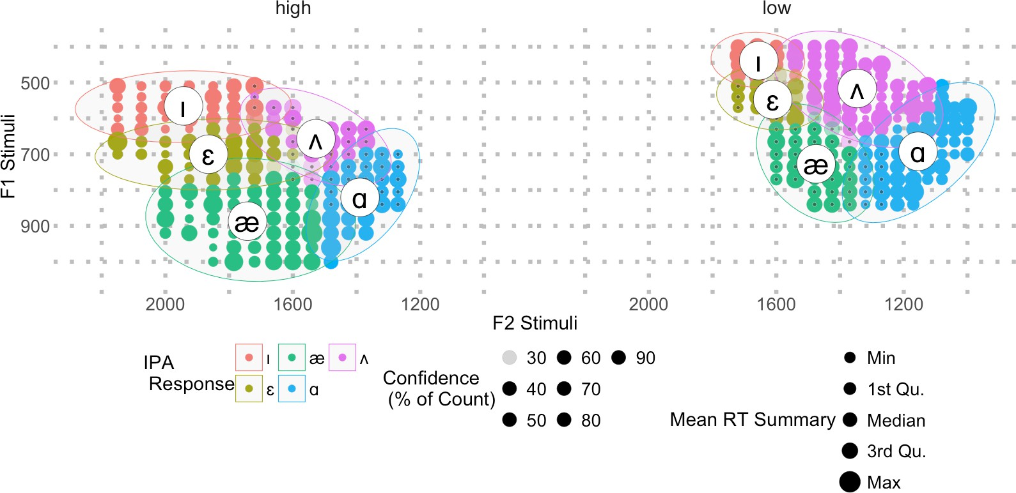

Figure 1. Perceptual categorization of synthetic vowels in a 5-AFC identification task (n = 87), plotted by F1 and F2 values across high-pitched (left) and low-pitched (right) voice conditions. Circle size indicates response consensus (% of count); darkness reflects mean reaction time. Ellipses enclose dominant perceptual regions by vowel category. Results show that stimulus voice pitch influences perceptual boundaries, particularly for /æ/, with high-pitched stimuli eliciting more retracted /æ/ categorizations, suggesting sensitivity to socially indexed phonetic variation.

The Effects of F0 Exaggeration on Mandarin Phrase Production in Intermediate L2 Adolescent Learners
Julia Howe, Lick Wilmerding High School, Polygence Research Program Colette Feehan, PhD, Polygence Research Program juliahowe88@gmail.com
cmfvoices@gmail.com

The acquisition of Mandarin lexical tones poses persistent challenges for second language (L2) learners, particularly adolescents from non-tonal language backgrounds (Kiriloff, 1969; Shen, 1989; Francis et al., 2008; Shen & Froud, 2019; Pelzl et al., 2019). While exaggerated pitch contours (Expanded-F0) have been shown to enhance tone perception (Cao et al., 2024), their effects on tone production remain underexplored, especially at the phrase level. This study investigates whether exposure to acoustically exaggerated input facilitates more native-like tone production in intermediate adolescent learners of Mandarin. Thirteen American high school students enrolled in intermediate Mandarin classes (ages 13–17, HSK 3+) completed a phrase-level imitation task, repeating 92 naturalistic Mandarin phrases recorded by a native speaker and digitally modified in Praat to create exaggerated pitch contours (Expanded-F0) alongside baseline versions. Native speaker judges rated production accuracy, and acoustic analyses assessed pitch contour alignment and variability.

Results revealed that Expanded-F0 input increased learners’ pitch variability but did not significantly improve native speaker ratings or contour alignment compared to baseline input. Greater accuracy was instead predicted by how closely learners replicated tonal contours, not by how widely they expanded their pitch range. Learners with more years of Mandarin study produced more native-like tones, while musically trained learners showed larger pitch modulation without corresponding accuracy gains. Participants frequently described the exaggerated stimuli as “robotic” or “unnatural,” suggesting that while the manipulation made tonal contrasts more noticeable, it also reduced the naturalness of the input.

These findings point to a dissociation between perception and production in tone acquisition: exaggerated input may highlight contrasts but can also lead to overshooting and distorted tones, particularly in less experienced learners. Pedagogically, the results stress the importance of training learners to match tonal contours precisely rather than simply expanding pitch range, and of adjusting the degree of exaggeration to learners’ proficiency. More broadly, the study underscores the need to design input that is both clear enough to draw attention to critical features and natural enough to support real-world use.

Tongue Root Advancement in Khalkha Mongolian with 3D/4D Ultrasound
Joshua Sims - Indiana University jodasims@iu.edu

In Khalkha Mongolian, plain consonants contrast with palatalized ones in words with RTR vowels, but not in words with ATR vowels. This asymmetry does not have an obvious phonological basis, since palatalization and ATR are not phonetically antagonistic.
However, Lulich and Cavar (2019) used ultrasound imaging to argue that palatalization in Polish is an expression of ATR. I performed a 3D/4D ultrasound imaging study of six speakers of Khalkha Mongolian, comparing laterals after ATR vowels with plain and palatalized laterals after RTR vowels in monosyllabic words. The ATR laterals had advanced tongue root position compared to the plain RTR laterals, but the palatalized laterals similarly had tongue root advancement, similar to those of ATR laterals and distinct from the plain RTR laterals. I argue that palatalized consonants in Khalkha are speciﬁed for the feature ATR, making them non-contrastive in an ATR environment. This corroborates other ultrasound studies which link ATR with palatalization or tongue body fronting, such as in Russian (Cavar & Lulich, 2021), Kazakh and Kyrgyz (Washington, 2019) and Irish (Bennett et al., 2018).

Tonal acquisition in a Second Language
Pin-Yu Chen¹ & Isabelle Darcy²
Second Language Studies at Indiana University;¹pinychen@iu.edu; ²idarcy@iu.edu

This study investigates how second language (L2) learners of Mandarin develop categorical
perception of lexical tones over the course of acquisition. English-speaking learners at different proficiency levels were recruited to examine developmental patterns.
L2 learners often struggle with perceiving or producing tones, especially when their first
language (L1) is non-tonal. Prior research has typically focused either on naïve listeners or on L2 learners at a single proficiency level (e.g., intermediate), leaving developmental trajectories
largely unaddressed. Studies of naïve listeners suggest that those from non-tonal L1s may lack categorical perception of tones (Halle et al., 2004), though they can still detect pitch differences (Burnham et al., 2015; Schaefer & Darcy, 2014). Moreover, pitch usage in one’s L1 has been shown to predict sensitivity to tonal contrasts in an L2 (Schaefer & Darcy, 2014). However, findings from L2 learner studies are mixed: some show advantages for tonal L1 speakers
(Wayland & Guion, 2004), while others suggest that L1 background does not reliably predict tone perception outcomes (Laméris et al., 2023).
To address this gap, this study employed a classic categorical perception paradigm using an ABX discrimination task and a two-alternative forced-choice identification (ID) task, alongside a
Chinese lexical decision test (LexTALE-CHI; Wen et al., 2024) to assess proficiency. Stimuli
were synthesized along a 10-step tonal continuum between Mandarin Tone 1 (55, high-level) and Tone 4 (51, high-falling). In the ABX task, participants heard three stimuli (A, B, X), where X
matched either A or B, and A and B were separated by two steps (e.g., step 1 vs. 3). In the ID task, participants saw two words (Chinese character with Pinyin and Zhuyin indicating Tones 1 and 4) and were asked to choose which word matched the auditory stimulus.
To date, 15 participants have been tested, including eight Mandarin L1 speakers and seven
English L2 learners (at beginner, intermediate, and advanced levels). Preliminary results showed that L1 Mandarin speakers exhibited robust categorical perception, with peak sensitivity in the ABX task and sharp transitions in the ID task. Beginners displayed relatively flat response
patterns, consistent with non-categorical perception. In contrast, intermediate and advanced
learners showed increasingly categorical responses, suggesting progressive acquisition of tonal categories.
Logistic mixed-effects modeling revealed significant differences between L1 and L2 groups, with pairwise comparisons confirming group-level distinctions. These findings suggest that categorical perception may initially be absent in learners from non-tonal L1 backgrounds but develops with increased L2 proficiency – a novel finding. Ultimately, advanced learners may approach tonal perception patterns found in L1 Mandarin speakers.
Additional participants of a tonal L1 group (Thai learners of Mandarin) will be recruited to shed light on the initial state of tone perception across L1 backgrounds and to test whether L1 tone categories facilitate or interfere with tone acquisition in L2. Possible mechanisms of categorical perception emergence will be discussed.

27
Prosodic Prominence and Sociodemographic Features in Heritage Chinese: A Multifactor Analysis
Brendan Dowling, University of Wisconsin–Madison Email: bcdowling@wisc.edu

I apply an individual differences approach to the domain of speech perception, building upon the production focused framework of Chang and Yao (2024). While previous research has documented a high degree of intergroup variation among heritage speakers (Chang 2021), most studies have focused on production. My study offers a new perspective on how the individual experiences of American heritage speakers of Standard Chinese (HSs) are reflected in their language processing patterns. I investigate both within and between group differences across three distinct listener populations–HSs (high exposure and low exposure), non-heritage Chinese listeners, and non-heritage English listeners. To do this, I combine data from a pre-experiment questionnaire and a prominence perception task to construct detailed listener profiles for each participant. I hypothesize that the variability observed in HSs' sociodemographic backgrounds is also reflected in their prominence perception patterns. Using multiple factor analysis (Lê et al.
2008), I analyze the relationship between individual listeners' sociodemographic features (e.g., language exposure, self-reported confidence) and their perceptual patterns (i.e., stress bias or lack thereof). Figures 1 and 2 (on page two) present scatter plots showing the projections of individuals based on their prominence perception and sociodemographic features, respectively, derived from the multiple factor analysis. The ellipses in these figures represent the 95% confidence intervals around the group means of the traditionally distinct listener populations, i.e., ‘FineGroup’. The results suggest that certain listener attributes, e.g., age of arrival in the U.S., provide greater insight into distinguishing listener groups, playing a significant (p < 0.05), if limited, role in shaping prominence perception profiles. This work underscores the importance of adopting an individual centered approach to listener classification–rather than the distinct listener populations we started with, and provides a novel approach for investigating prominence perception in Standard Chinese.

References
Chang, Charles B. 2021. Phonetics and phonology of heritage languages. In Silvina Montrul & Maria Polinsky (Eds.), The Cambridge handbook of heritage languages and linguistics (pp. 581–612). Cambridge, UK: Cambridge University Press.
Chang, Charles B. & Yao Yao. 2024. An individual-differences perspective on variation in heritage Mandarin speakers. In Rajiv Rao (Ed.), The Phonetics and Phonology of Heritage Languages (pp. 208–236). Cambridge, UK: Cambridge University
Lê SébaPsrteiesns., Josse Julie, & Husson François. 2008. FactoMineR: An R Package for Multivariate Analysis. Journal of Statistical Software, 25(1), 1–18. 10.18637/jss.v025.i01

1

Data
(Figure 1)
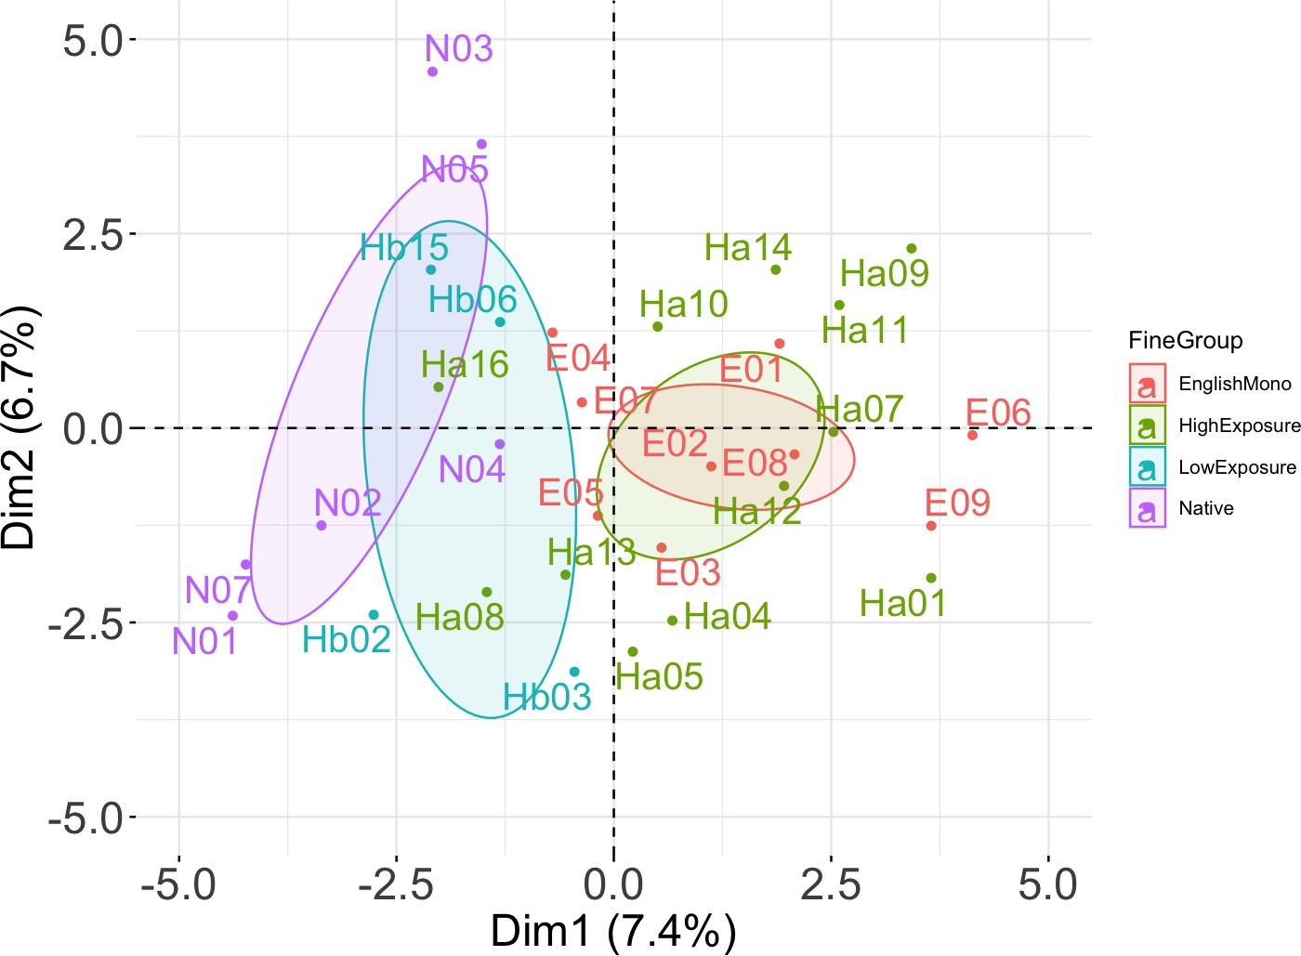
(Figure 2)
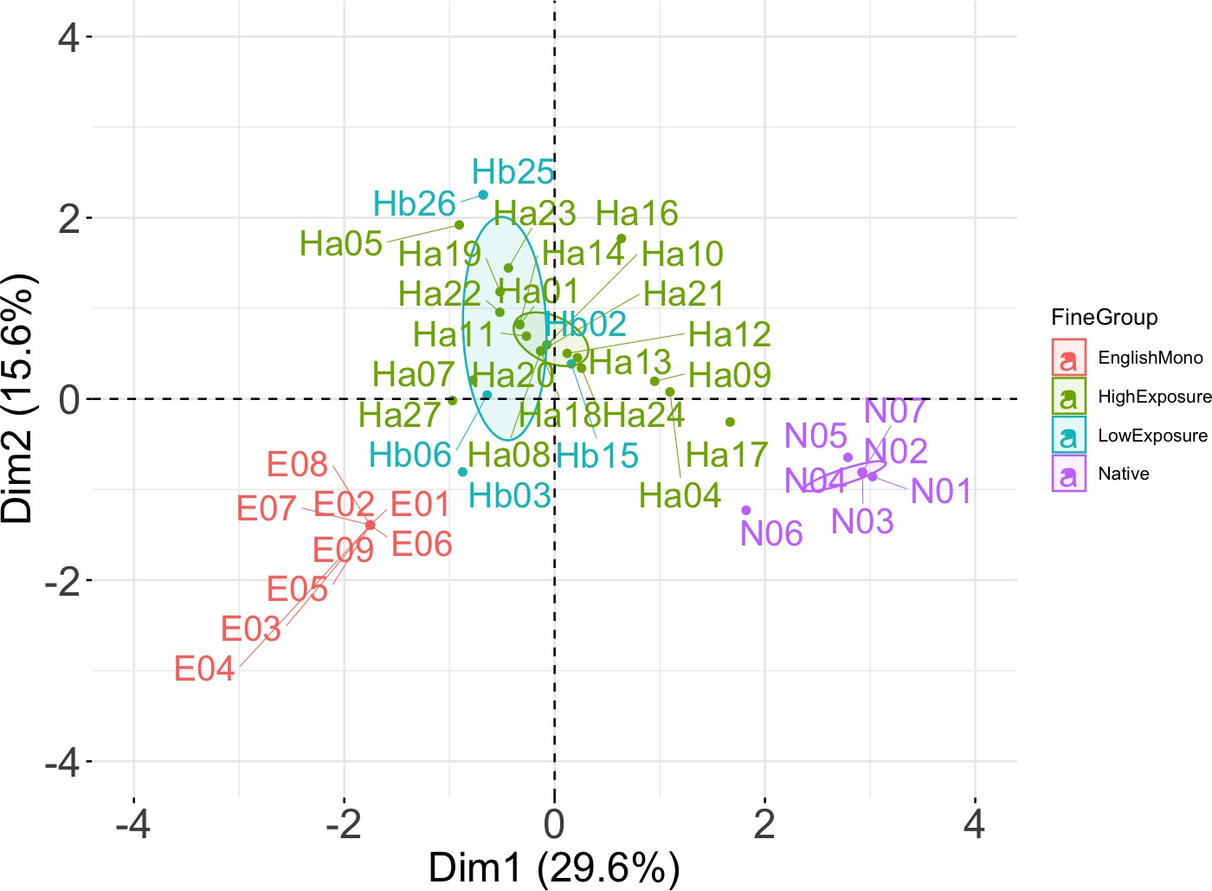

2

28 Limits on phonemicization: Evidence from Japanese loanwords
Drake Howard, Michigan State University howar379@msu.edu

In this presentation, I argue that languages cannot innovate a non-native phonemic distinction if an analogous quasi-phonemic distinction is not already present in the language. I observe that in accordance with this limit, while modern Standard Japanese has innovated a fully phonemic distinction between /t/ and /tɕ/ in loanwords from English (mirroring the contrast between English /t, tʃ/), it shows no signs of developing a contrast between /ɾ, l/ to reproduce the English /ɹ, l/ distinction. I propose that Japanese has gone through three different diachronic stages relevant to the phonologization of /t/ and /tɕ/, and that modern Japanese is currently incapable of developing a contrast between /ɾ, l/ because [l] has not even reached that first stage. This analysis is couched in Stratal OT (Kiparsky 2015a), which theorizes that phonological processes take place over multiple iterations subject to different constraint rankings between the morphological stem, word, and postlexical levels.
Phonologization took place in three stages, each of which involved stem-level, lexical, and postlexical strata with distinct rankings. In the first stage, corresponding to Japanese when it first encountered loanwords from English, [ts, tɕ] were categorical conditional allophones of /t/ before /u, i/, respectively. No distinction between [t] and [ts, tɕ] existed at this stage for native speakers, so when borrowing the first English words with [t] like “suit (clothing)” and “tree” that violated native syllable structure requirements, they inserted the default epenthetic vowel /u/, resulting in /t/ being realized as an affricate: [suːtsu, tsuɾiː].
In the second stage, [t, ts, tɕ] were reanalyzed as quasi-phonemes (Kiparsky 2015b), meaning they were not distinct at the stem-level phonology, but were distinct at the word-level phonology. As a result, although the three were still in complementary distribution, speakers were now sensitive to the perceptual differences between them. Evidence that speakers perceived
[t] as distinct from [ts] is found in the fact that, except for those early first-stage loans, English words with coda or preconsonantal [t] have consistently been borrowed with an epenthetic /o/ rather than /u/ so as to avoid affrication, as in [suːto] “suit (cards),” [toɾiːtomento] “treatment.” However, because /t, ts, tɕ/ all corresponded to the same underlying segment at the stem level, distinctions between [t, ts, tɕ] could not always be preserved; stem-level /tu/ and /ti/ in loanwords still had to be realized as [tsu] and [tɕi] (e.g. [tsuːɾu] “tool,” [tɕiketto] “ticket”) because the alternative would be to fatally violate stem-level markedness constraints.
In the third stage, corresponding to the present, /t, ts, tɕ/ are all separate phonemes contrastive at the stem-level phonology as evidenced by their distributions in recent loanwords, which resulted in pairs like [tekku] “tech” vs. [tɕekku] “check” and [tutti] “tutti” vs. [tsutɕi] “earth.” In contrast, English onset /ɹ, l/ continue to be neutralized in loanwords because [l] has never been a conditional allophone of /ɾ/, since it’s capable of varying with [ɾ] in all positions (Okada 1999).

29
Title: Speaking of memory: acoustic cues to accuracy Authors: Kristin J. Van Engen, Ruth Altmiller, and Ian Dobbins ACiliation: Washington University in St. Louis
Email: kvanengen@wustl.edu
Format preference: oral (willing to do either)
Scheduling preference: Saturday preferred (Friday evening is not out of the question)

Imagine a juror evaluating the testimony of an eyewitness or a spouse considering a partner’s claim that they’ve already taken their daily medication. Although we regularly evaluate the ﬁdelity of other people’s memories based on what they say about them, the cognitive mechanisms enabling social metamemory are largely unknown. This project is laying a foundation for understanding how people convey the accuracy of their own memories and how they evaluate the memory accuracy of others. It builds on prior work that has examined the language used in written memory reports and expands it to spoken reports. Under the central hypothesis that speech carries accuracy information about memory that is dissociable from what can be captured in written reports, we are examining how individual diCerences in speakers and listeners inﬂuence the eCicacy of social metamemory communication. This presentation will report on the initial phase of this project, which aims to identify individual diCerences in signaling eCicacy. In addition to a set of cognitive and metacognitive measures, we are investigating measures of speech rate, loudness, and pitch.

30 Short Major Syllables in Ngalang Zophei: An Epilogue
Samson Lotven (slotven@iu.edu) and Van Nei Par – Indiana University

In Zophei and other languages in the Maraic branch of South Central Tibeto-Burman (SCTB), a reduction in the number of allowable syllable shapes has occurred alongside complexification in vocalic and tonal systems. While more conservative Hakha Lai retains length distinctions in open and closed syllables and permits coda liquids, nasals, and
stops; only some Maraic languages have length distinctions in “major” (prosodically prominent) syllables, and they permit only nasal codas, if any. The Maraic languages with the most restricted syllable shapes are Lutuv, which features coda velar nasals and only long major syllables, and Zotung and Mara, with no codas but short and long major syllables (Lotven et. al, 2019).
As in other SCTB languages, Zophei organizes its prosodic words into right-headed feet, consisting of a “major” syllable and any number of preceding short “minor” syllables where the vowel is reduced, in this case always /a/.1 Major syllables in other Zophei
varieties such as Tlawngrang, Lawngtlang, and Nuitah may be short and open (CV), long and open (CVV), or long and closed with a velar nasal (CVŋ). Ngalang Zophei differs from other Zophei varieties in disallowing short major syllables. This presentation examines the ramifications of this innovation for the vocal, tonal, and prosodic systems.
Consider the following example of two underlyingly short syllables; while nearby Lawngtlang Zophei has [tsá hlaˈ], Ngalang Zophei has [tsà hlààˈ] ‘to shake,’ where the prominent syllable on the right is long in the latter and has Low tone. In other Zophei
varieties, Low tone is rare. In the corpus of Lawngtlang Zophei words in Lotven (2021), only 2 monosyllabic words are identified with Low tone, that is negative /bè/ and irrealis /àà/, it is largely found in disyllabic words in combination with High and Toneless syllables. Nearly all of these underlyingly short syllables in Ngalang have Low tone, offering a new category of verb, and collapsing previously High and Toneless categories.
There is evidence that these verbs are still underlyingly monomoraic. When the verb
/sà/ ‘to build’ appears on the right edge of a foot, as in [ka saa] ‘I built it’, it is long, but
before the question marker /móó/ in [na sa móó] ‘Did you build it?’ it is short. This effect is not the same for other vowels, although tonal evidence suggests they too are still
monomoraic.

Ngalang Zophei data are from the second author, a native speaker, while data from other varieties of Zophei, as well as Lutuv are from Lotven (2021).

1 Here, as in many languages of South and Southeast Asia, /aa/ sounds like [a], and short /a/ sounds like [ə]. Also, High and Low tone are marked as <x́> and <x̀>, respectively, and prosodic prominence is marked here with <xˈ> following the prosodically prominent syllable.

References

Lotven, S. (2021). The sound systems of Zophei dialects and other Maraic languages [Doctoral dissertation]. Indiana University.

Lotven, S., Berkson, K., Wamsley, J. C., Danaher, J., Van Bik, K., and Davis, S. (2019). The syllable in Kuki-Chin. Journal of South Asian Languages and Linguistics, 6(2). 1-28

